

Social Media Site(interact)

Shree S . C . Gandhi B.C.A College , Botad

Year: 2023

Develop by : Mr. Bhavesh Chavda

Submitted to : maharaja krishnakumarsinhji Bhavnagar university ,bhavnagar

­­

FRONT : BACK :

HTML , CSS , PHP , MY SQL

JAVA SCRIPT

Guided By:

Jayesh Sir , Bhumika medam

Abstraction

* My motivation of making this project is MARK JUKERBERG who founder or cofounder of FACBOOK social media site.
* When I joined my first day of college that time I thought I will create my best application .
* and first photo came over my face who person is MARK JUKERBERG and bill gates.
* I inspire this person and his simplicity . mark is vary simple look and behavior
* He leave simple 2 BHK flat . and his have only 7 T-shirt how good person he.!
* His thought “simple living high thinking”.
* He doesn’t made his life complicate to waste on thing. I like her thought .
* I can’t made social media site like his .but I try my best and create less similar site.
* I also thank my favorite app you-tube which always help to make my site I think it is best app create in all over word and provide education.
* Some logic and design make using you-tube. I also thank you-tuber who provide deep learning in programming language.
* I want good programmer And make use full software and site.
* My dream is in life I want bilinear.
* I am not good at theory but good at programming .
* When I start my project I did not think I made this project but it done
* Many obstacle came when I develop this site but I never stop keep leaning and make this project.
* Big obstacle when I make this project is my father accident that time I think I stopped this project and take care my father I stopped my project .
* I recover my self and again start this project. That is big turning point of my life.
* My roll model Is “ SWAMI VIVEKA NAND – WAKE UP GET UP AND KEEP DOING WORK UNTI ACHIVE GOLE”.



index

|  |  |  |
| --- | --- | --- |
| Chapter | Content | Page |
| 1 | Planning(indroduction) | 6 |
|  | 1,1 background | 10 |
|  | * + 1. front end tools |  |
|  | 1.1.2 back and tools |  |
|  | * 1. objective | 14 |
|  | 1.3 purpose | 15 |
|  | 1.4 scope of system | 15 |
|  | 1.5 applicability | 16 |
| 2 | Requirement and analysis | 18 |
|  | 2.1 problem definition | 18 |
|  | 2.2 requirement specification | 19 |
|  | 2.2.1. User interface Requirements | 19 |
|  | 2.2.2. Functional Requirements | 20 |
|  | 2.2.3. Nonfunctional Requirements | 21 |
|  | 2.2.4. Performance Requirements | 22 |
|  | 2.2.5. Logical database Requirements | 23 |
|  | 2.2.6 Technical Requirement | 24 |
|  | 2.3. Hardware software requirement | 25 |
|  | 2.4. Planning and scheduling | 26 |
| 3 | overall system designing using designing tools | 27 |
|  | 3.1.1 Data Flow Diagram | 28 |
|  | 3.1.1.1 -level DFD | 29 |
|  | 3.1.1.1 -level DFD | 30 |
|  | 3.1.1.2 -level DFD | 31 |
|  | 3.1.2 UML Diagram | 32 |
|  | 3.1.2.1 Class Diagram | 33 |
|  | 3.1.2.2 Activity Diagram | 34 |
|  | 3.1.2.3 Use of case Diagram | 35 |
|  | 3.1.3 E R Diagram | 35 |
|  | 3.2 Data Dictionary | 36 |
|  | 3.2.1 List all database table with description | 36-40 |
|  | 3.3 Input/Output Design | 40-42 |
|  | 3.4 Design | 42-68 |
| 4 | Testing and implementation | 69 |
|  | 4.1 Testing and Approaches | 70 |
|  | 4.1.1 unit Testing | 70 |
|  | 4.1.2 performance Testing | 71 |
|  | 4.1.3 system testing | 71 |
|  | 4.1.1 back-end testing | 72 |
|  | 4.1.2 White box testing | 72 |
|  | 4.2 test cases | 73 |
|  | 4.3 Implementation Approaches | 74 |
|  | 4.3.1 parallel Approach | 75 |
|  | 4.3.2 phased approches | 76 |
|  | 4.3.3 waterfall approches | 77 |
|  | 4.3.4 Spiral Model | 78 |
| 5 | Conclusion | 79 |
|  | 5.1 Limitation of System | 80 |
|  | 5.2 Future Scope of system | 81 |
|  | 5.3 Bibliography | 82 |
|  | 5.4 Webliography | 83 |

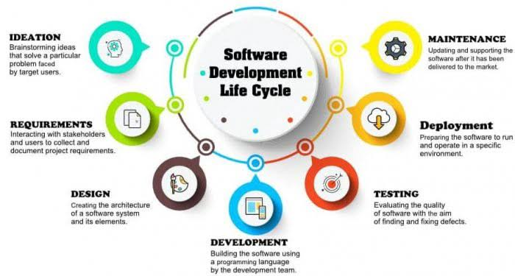

1 . Planning

1,1 background

* + 1. front end tools
    2. back end tools
  1. objective
  2. purpose
  3. scope of system
  4. applicability

Introduction

### Introduction.

Social media represents a vast online community where customers, partners, suppliers, and shareholders come together to share information, promote products and services, and exchange opinions and experiences. [**Interact**] recognizes the limits and risks of social media, and how it can affect our project's brand, public image, and core values. Therefore, we have created this social media policy to lay out a framework of tested social media guidelines and protocols.

**Corporate Use.**

Employees that are responsible for representing the project on social media are required to uphold the project's image, core values, and brand. Subsequently, [**interact**] expects all employees to remain fair, professional, and polite to any [**interact**] partners, , customers, members

**Social Media Guidelines:**

* Avoid speaking on and/or posting about subjects outside of the project's expertise.
* Reply to all comments in a timely manner.
* Correct or delete incorrect and/or misleading content.
* Adhere to the project's confidentiality agreement and anti-discriminatory policy.
* Avoid posting and/or sharing offensive, discriminatory, and/or false information.

[**Interact's**] Social Media Manager and Marketing Manager are responsible for setting up an official [**weekly/monthly**] social media calendar. The social media calendar must be approved by a senior executive or manager at least [**number of days**] before the start of a new month. In cases where the project is set to announce major news or launch campaigns on social media, the Social Media Manager and Marketing Manager must thoroughly review the content for any misleading or incorrect information.

**Personal Use.**

To ensure optimal productivity, [**interact**] allows its employees to access personal social media channels at work for at least [**number of hours**] per day. We do ask our employees to be responsible with their time and always ensure deadlines and job responsibilities are completed on time.

While [**interact**] recognizes that we may not prohibit our employees from posting personal opinions and content on private accounts, we do expect our employees to uphold the highest level of respect and adhere to our project's anti-discriminatory and harassment policies.



Unit 1 Planning

In recent years, the need to be a part of some sort of online community has increased. With more and more people spending so much time on social media, there are increasing worries about how sites like Interact might be affecting our everydays life. Nowadays, normal life standards require having a social media profile, communicating and sharing your personal info on the web. Social media sites just keeps growing and growing.

So why not to create your own one! The market for this industry exists, and recent statistics shows that the demand for social communication is only increasing. According to recent research by MarketingSherpa, 95 % of the online adults aged 18 – 34 most likely follow a brand via social networking. There are 2.56 billion global mobile social media users, or 34% penetration and 1 million new active mobile social users added every day according to We Are Social. This infographics about social media users’ growth confirm There is a demand; all you need to do is to find the right tools and tips to make such platform. Follow these 4 steps to start your own social media site

1. Conduct a Quality Market Research

There are many available marketing research tactics, which you can use to shape your marketing persona. When conducting this study, you can get two types of data: primary and secondary. - Primary data gathers information directly from the source or your customers. This method involves tactics like surveys, focus groups and interviews.  
  
Secondary data sources are related to statistics and infographics. This method includes reports, studies, and information from official authorities and associations. The ultimate goal is to define how your social media site will affect them, what they really want as a service and what you can do to improve and offer a better solution.  
  
2. Define Basic Social Media Features Plan  
  
You need to prepare a complete social media features plan that will be based on your customer database. Use your market research findings to compose a plan that wraps up everything your users would desire in one place. Following their needs, the development process of the social media features plan is the most important step when creating a social media site.  
  
You have to take into consideration everything: news feed, messaging, groups, profile looks, buttons, status updates, comment sections, privacy policy etc. The list is long, that is why you need to organize everything in a plan and have a clear overview of the defined things and cracks that need improvement.  
  
Finally, you need to know what type of interface will trigger engaging reaction among the users. User centric interface means that you need to create an intuitive mapping between user’s intention and application’s function that enables a solution to a given task. The way people interact with your site and how they access its functions is greatly affected by the quality of the user interface.  
  
There are typical UI features of social media and networking sites. You need to go through this process in order to create all of the things we mentioned above.  
  
3. Run Demo Tests on Real People and Promote

After finishing with the defining processes and starting a social media site, you need to run a trial period. Testing the demo version on your customers will help you define the bottlenecks, issues, and errors. This stage will make you finalize your product and improve existing bottlenecks. The last step is to promote your product. Digital marketing has multiple techniques that can help in getting your social media site out there. Email Campaigns are the efficient and inexpensive way to increase awareness on the market. Create a reliable database by using lead generation techniques, design newsletters and expect results.

Front-End development

* What is HTML?
* HTML is a language for describing web pages.
* HTML stands for hyper text mark-up-language.
* HTML is a mark-up language.
* A mark-up language is a set of mark-up tags.
* The tags describe document content.
* HTML document contain HTML,tags and plain text.
* HTML document are also called web pages.

Web Browsers

* The purpose of a web browser (such as Google chrome internet explorer,
* Firefox, safari) is to read HTML documents and display them as web pages.
* The browser does not display the HTML tags, but uses the tags to determine how the content of the HTML page is to be presented/ displayed to the user.

What is CSS?

* CSS stands for cascading style sheets.
* Styles define how to display HTML elements
* Style were added to HTML 4.0 to solve a problem
* External style sheets can save a lot of work? External style sheets are Stored in CSS file
* Java script
* Java script will be used for sites in making the same external function such as zoom-in-out , view replacement photos in the same place of pages.

Back-end

PHP

* PHP is a widely used ope-source general-purpose sever-side scripting language.
* PHP is a hypertext processor , which is a widely used open-source programming language means that is free to use PHP there is no need to purchase any license for work in PHP.
* PHP also stands for “personal Home Page “ which is the old name for PHP.
* PHP is a server-side programming language for website development.
* It is dominant toll which can be used to develop dynamic website.
* It was designed by rasmus leadoff and PHP group in 1995.
* PHP is especially suited for web development and can be embedded into HTML.
* PHP files are returned to the browser as plain HTML.
* PHP files have a file extension of “PHP” ,”.PHP3”, or “.PHTML”.

Operating system

* PHP is a cross-platform. It can run on many operating systems.
* Linux
* Mac
* Window
* Unix

Supported database

* MySQL

PHP development tools

* WAMP stands for “window , Apache , MySQL and PHP”
* WAMP is a variation of lamp for windows systems and is often installed software (APACHE , MYSQL and PHP)
* In is often used for web development and internal testing but may also be used to serve live websites.

Sublime text

* Sunlime text is one of the leading text editors out there for PHP developers.
* This cross-plat form source code editor natively supports several programming as well as markup languages.
* With its feature rich functionalities and extraordinary design, it makes the developer community consider the text editor as the best ide for PHP
* Being a leading customizable text editor with custom Ul toolkit , words or lines using appropriate key shortcuts. Moreover you can make changes to any line of your code.

Sublime text features

* Split editing.
* Instant project switch.
* Better command palette.
* Distraction fee mode.
* Plugin API

Objective

* Main objective of this site is “ वसुदेव कुटुंबकम ” –word become family
* Interact is social media site which help you to interact people with each other.
* Interact so many feature that allow people more close .
* Using this site, long distance area people can chat with each other and also share memory , photo , video , and other information.
* Though this site people can make relationship unknown person.
* In this now day many people feel lonely using this site (messenger) chat with each other and relationship.
* Using this site also useful to job section . this site provide profile section bio data facility user can write her bio data education detail : school , collage ; marital status ; city ; which place work ? ; what kind of work ? facility.
* But now day social media instead of make close people it make so long distance between relationship .
* So that interact founder Mr. bhavesh improve site and add new future to close people more interactivity provide .
* This site is totally tribute of MARK JUKERBERG.
* In this site no any age restriction to join as family .
* Using this site people more explore word.

**Highlights of this networking site**

* Registered user can create their profile which will contain their details such as personal, educational, interests etc.
* Once registered can follow other users of the site and add them to friends list.
* Users can send messages online to friends in profile list which may include interact messnger as well.
* Users will have an inbox and outbox containing received and sent messages
* Users can upload photos of their own which their friends would be able to see and comment upon
* Users can set theam settings for their  site.
* Users can begin or join any communities they are interested in, can post messages in these communities as well.

**Purpose.**

* This social media site main purpose is make interaction between people in this hat tic life so much tension reduce this tension and interact or communicate with people in any place of word without physical and share thought , event , post , message or know people
* The purpose of this social media policy is to (a) outline the social media guidelines and protocols of the project, (b) define the rules that apply to both corporate and personal social media use, and (c) to explain the project's disciplinary action process for policy violations.
* Interact is social media site which help you to interact people with each other.
* Interact so many feature that allow people more close .
* Using this site, long distance area people can chat with each other and also share memory , photo , video , and other information.
* Though this site people can make relationship unknown person.
* In this now day many people feel lonely using this site (messenger) chat with each other and relationship.
* Using this site also useful to job section . this site provide profile section bio data facility user can write her bio data education detail : school , collage ; marital status ; city ; which place work ? ; what kind of work ? facility.
* But now day social media instead of make close people it make so long distance between relationship .

**Scope.**

This social media policy applies to all [**interact**] employees, including paid interns, volunteers, contractors, and seasonal, part-time, and full-time employees. [**Interact**] defines social media as any form of electronic communication or application that enables users to create online communities and share knowledge, opinions, media, and private messages.

● To have attractive and Secure Login page to access

● Make new user account in more user friendly and proper validation of details

● Search People easily on entire network

● Send Friend Request to other users to make friends

● Add friends to your friend box accept request

● Creating a public profile having social, professional and personal information

● Ease of editing of profile anytime

● Chat with Online friends

● Upload and Share Images on network

● Add, Search and shares videos of youtube

● Send messages to other friends

● Reply directly to incoming user messages

● Post Advertisement of products

● Administration page to keep eye on user operation

● Easily password recovery processi

Applicability

* Most people use different social media platforms on a daily basis. Whether you use social media for marketing, personal communication, entertainment or to keep up with trends, it can become an integral aspect of your routine. The ability of social media to thrive is based on the growing need for people to have faster access to information and share it with each other.
* Advancements in technology have eased the process of relaying and made it easier to express varying views on social media. The positive effects of these platforms are an area of focus as more people become aware of how the influence of social media has transformed society. The rising popularity of social media is not only changing how people communicate but changing business operations, governance and daily aspects of life at a rapid speed as well.
  + The main objective of the proposed social media site is to computerize the existing system and reduce manpower and time consumption
  + It provides the following features
  + Which language you work decided
  + Which database you used to store user data
  + Which feture use in the social media web site
* Social media provides a forum that people can use to support each other during difficult moments. During various challenging situations around the world, including natural disasters like hurricanes and earthquakes, people have relied on social media as a practical way to communicate.
* Many people turn to sites such as Twitter, Facebook and Instagram to provide details of events and let their family and friends know they are safe. Tragic occurrences often mobilize social media users around the world to provide valuable information and supported the people who have been affected.
* Networks promote hashtags to spread awareness and increase avenues for support. Social media can help to keep people safe when they are about dangerous areas that should be avoided and providing safety tips during emergencies.

2. Requirement and analysis

|  |
| --- |
| 2.1 problem definition |
| 2.2 requirement specification |
| 2.2.1. User interface Requirements |
| 2.2.2. Functional Requirements |
| 2.2.3. Nonfunctional Requirements |
| 2.2.4. Performance Requirements |
| 2.2.5. Logical database Requirements |
| 2.2.6 Technical Requirement |
| 2.3. Hardware software requirement |
| 2.4. Planning and scheduling |

Unit 2 Requirement and analysis

The analysis stage includes gathering all the specific details required for a new system as well as determining the first ideas fro prototypes.

Developers may:

* Define any prototype system requirements
* Evaluate alternatives to existing prototypes
* Perform research and analysis to determine the needs of the end-users

Furthermore developers will often create a software requirement specification or SRS document . this includes all the specifications for software , hardware , and network requirement for the system they plan to build . this will prevent them from overdrawing funding or resources when working at the same place as other development teams.

* Problem definition:
* In now day life is vary fast and hat tic people grow day to day . new technology come vary fast. People demand grow every day but resource are not enough that way reason people disappointed. People feel lonely they want entertainment in life . some people suffer from loneliness and feel tress in life if people feel loneliness and tress than chronic deceases , mental disorder , depression feel
* Some other problem are also like social awareness. In over india so many problem poverty , economy , gross domestic product , crime , rape , political scam , bank robbery etc.. so many problem
* Above all problem solve using social media site and social awareness so many social aware NGO interact with social site and help orphan child. Using social site aware people “save water” “save tree” “save girl” many important topic .
* Now day social media site also provide online work from home facility using social site people or employ can work home interact with site. Company can easily communicate with live video call conference , or share document and photo video .
* The most important future of social site is entertainment in this tressfull and busy life social site provide entertainment like funny comedy video , gamming , explore word , educational video , technical video , daily life use full video , health related video , traveling etc….
* Social media site made for solved many kind of problem .
* This site made for special interaction people without touch physically.
* Over the internet user can communicate easily with each other.
* Making problem of site
* They are many problem face to making this site they are following bellow.

1. Which language we use to make this site.
2. Which database use to make this site.
3. Which future are provide in this site.
4. Provide high security to user.
5. Main thing algorithm of this site.
6. How many day to develop this software.
7. Which kind of design layout make for this site.

* Requirement specification

Functional requirement

* Every app need function
* Function in programming language definition : ” function is block of code or group instruction and perform certain action when it call”
* But hear we also use programming function and non programing function
* Firs of all programming function :
* Like hear we use lot of function like-function , follow function , unfollow function , unlike function , fetch data function , login function , sign up function , add post function , add-photo function , add-video function , send message function ,post-comment function .
* Like function use to insert like in database which user like which post.
* Follow function use to follow person .
* Unfollow function use to unfollow user.
* Login function use to access user and provide protection and security.
* Add post , add-photo , add-video function insert video , image
* Send message function use send message particular user or chat.
* Send comment of particular post use add-comment .
* Other function are also make but right now above enough . basically each new feature we make new function.

User interface requirement

* In this site user interface is vary important because base on user interface people make more user friendly.
* Interface basic definition is “design of project” .
* If user interface more attractive than more people visit app.
* It is one kind of front-end which we make HTML and CSS and other component.
* It’s also we can say error handling in this face more important is error handling .
* When error will arise then specific message seen user .
* Specially run time error at that time your program suddenly not terminate . this kind of error user make wrong impression .
* It is vary tough to understand error and make algorithm and logic.
* Some other point are also important when app process that time particular messages seen at interface as example: processing or progress bar.
* Also provide yes or no , ok , cancel , go , next , back , previous , open , close etc… kind of button.
* We also determine color combination of desk and other component like over theme no light color like red . blue or white color enough for eyes.
* Over app must be GUI ( graphic user interface ) it’s app make more attractive and uneducated people can understand .
* Font size and it’s color can must readable format.
* Arrow size regular so user can seen and click object of app.

Non Functional Requirements:

* In this face programmer define basically that aspect which not technical related with app.
* It is not specific some situation it change aspect it dependent of topic which topic we make it’s example if we make social media app than make it diagram how it work it called non-functional requirement.
* In this system there is a risk of unauthorized access.
* So in this system we have to give appropriate username and password
* The system is highly interactive with databases at each and every point of addition, deletion and updating records.
* System must be user Friendly .
* System must be reliable, accurate and specific .
* Also include design of project. How can make it plan also include it.
* Non function is predict of some thing that we emigenestion.
* In social media require non function like theme , intensive , objective .

Performance Requirements

* Since its inception, social media has developed rapidly to become an online marketing game-changer. It offers some valuable advantages compared with other advertising channels. First of all, it is an incredibly rich source of user data, making it an exceptional tool for targeting users. Some companies treat is as a full-fledged platform for brand launch and further promotion. Overall, social media is an important driver for increasing reach and ROI.
* The question is this: how do you know that you are doing social media marketing right? Above all, you need to focus on the following criteria: engagement, reach, and conversion. Below, you will find a brief guide to make the most out of these metrics.
* **Engagement** is of utmost importance. It defines the performance of the rest of social media KPIs. It comprises the number of likes, shares, comments, and brand mentions. For Facebook and Twitter, high engagement reflects the popularity of the content. As a result, more users see your updates in their news feeds. When monitoring engagement, leverage the following metrics: **clicks, likes, shares, comments, brand mentions, active followers, and profile visits.** They reflect the general attitude of users towards your content. This can be ignorance, neutrality, interest, dislike, or commitment.
* In case you have large reach with low engagement, there must be something wrong with your content. It does not properly resonate with the audience. Try to change your approach, test various titles and visuals.
* Another thing to keep in mind is **visibility**. The more visible your content, the more eyeballs it gets. Depending on your target audience, make sure to use relevant social media platforms. To measure reach, you need to monitor the number of followers, impressions, and traffic data. **Followers** are people willing to see your content on a regular basis. The more followers you have, the better. As [Global Web Index](http://blog.globalwebindex.net/chart-of-the-day/trends-2016-social-commerce/) data shows, 37% of online users follow their favorite brands on social media. **Impressions** display how many times your posts actually showed up in the news feed. The number of impressions grows if someone liked or shared your post in their timeline (taking Facebook for instance). However, users could potentially see it but not click on it. For this reason, it is pretty hard to make accurate calculations. **Traffic data** is the percentage of actual traffic coming to your site from social media platforms. If the number is high, your marketing campaign is going well.

Technical Resources:

* The technical resources of this project are merely for computer base system purposes.
* his Project is intended to be developed using the PHP programming language.
* Data shall be stored in PhpMyAdmin is a free and open source administration tool for MySQL
* We need in this project technical knowledge because now day internet is vary popular and knowledge wisdom. You can find out any resources using it’s.
* Because it is technical project so more related or used more technology
* We also need server to run it like WAMP, XAMMP
* Also run at internet need global server like HOSTINGER , GODADY etc….
* Also need database like MYSQL, SQL ,BASE etc…
* BOOSTRAP , REACTE , plugin , technical link .

Logical database requirement

* The most common database designs for social networking sites include quick reference functions, features for the addition and removal of social media sites and channels to your own database and the ability to filter sites based on multiple features.
* Almost 3 billion people use social networking sites regularly. 1.2 billion People use Facebook monthly, and Twitter is catching up fast too. There is an incredible amount of data you can find on these online sites. Social media and social networking depend on each other, although the terms are not interchangeable. Social media includes blogs, vlogs, images, news articles, social network posts, and pictures.
* As you can understand already, social media management also involves the management of big data from multiple sources. Big data is like the bigfoot of the business world. However, you need to rendezvous with the very basics of big data management if you want to utilize your social media channels for marketing success. Once your business profile is up and running on multiple channels, you will get terabytes of data each day. There is no other way to manage this monumental amount of information unless you can find a reliable database or design one for yourself.
* Designing a database for a business is not a joke. Even with the best expert programmer, it can take you months to create the perfect database with all the right indexes, fields and sorting system. You need an existing database, which is flexible, yet secure. You need to include backup features along with regular monitoring and recovery systems.

### Hardware requirement

|  |
| --- |
| Server Side: |
| • Core 2 Due 2.4GHz and Above |
| • 2 GB of Random Access Memory and Above |
| • 160 GB Hard Disk |

|  |
| --- |
| Client Side: |
| • Pentium-IV 1.5MHs and Above |
| • 512 MB of Random Access Memory and Above |
| • 80 GB Hard Disk |

|  |
| --- |
| Software Specification: |
| * Environment : Wamp server |
| * Technologies : Apache |
| * Database : My SQL |
| * OS : Windows xp , vista , 7/8.1/10/11 |
| * Browser : Microsoft adg , CHORME etc…. |

SOFTWARE REQUIREMENTS User Requirements:

● Operating System : Windows.

● Web Browser : All Standard Web Browser (Internet Explorer, Mozilla Firefox, Google Chrome)

Web-server: Apache Web Server Database Server

● My SQL 5.0 PHP Version

● PHP 5

Planning and scheduling

* When you’re a social media project manager, you manage social media marketing campaigns. That means overseeing campaign planning, content creation, scheduling posts across various platforms, tracking analytics, and more.
* To manage social media campaigns on this kind of scale, project managers typically rely on project management software — and one of the premier project management tools for marketing teams is Teamwork. This platform lets you automate workflows, track progress, assign tasks out to team members, and more, all from one centralized dashboard.
* Traditional project management usually focuses on producing a product or service. Social media project management’s product is a series of social media marketing campaigns.
* Both types of project management include an element of customer interaction — but for social media projects, it’s all about the customer. Traditional project managers need to account for customer feedback and customer pain points to guide their teams in creating desirable products and services. Social media project managers, much like [marketing project managers](https://www.teamwork.com/blog/what-makes-a-successful-marketing-project-manager/), need to do a deep dive on their target audience, learning as much about them as possible so that they can guide their teams in creating campaigns that resonate.

As an example, let’s examine a campaign that focuses on [social proof](https://sproutsocial.com/insights/social-proof/). To create social proof, you’ll need some Instagram posts featuring influencers enjoying your product. Your team’s workflow and approval process will look something like this:

* Reach out and engage with influencers.
* Brainstorm image ideas.
* Approve ideas and assign a photographer to create them.

3 . overall system designing using designing tools

|  |
| --- |
| 3.1.1 Data Flow Diagram |
| 3.1.1.1 -level DFD |
|  |
| 3.1.1.1 -level DFD |
| 3.1.1.2 -level DFD |
| 3.1.2 UML Diagram |
| 3.1.2.1 Class Diagram |
| 3.1.2.2 Activity Diagram |
| 3.1.2.3 Use of case Diagram |
| 3.1.3 E R Diagram |
| 3.2 Data Dictionary |
| 3.2.1 List all database table with description |
| 3.3 Input/Output Design |

Unit 3 overall system designing using designing tools

## **What is a data flow diagram (DFD)?**

* A picture is worth a thousand words. A Data Flow Diagram (DFD) is a traditional way to visualize the information flows within a system. A neat and clear DFD can depict a good amount of the system requirements graphically. It can be manual, automated, or a combination of both.
* It shows how information enters and leaves the system, what changes the information and where information is stored. The purpose of a DFD is to show the scope and boundaries of a system as a whole. It may be used as a communications tool between a systems analyst and any person who plays a part in the system that acts as the starting point for redesigning a system.
* It is usually beginning with a context diagram as level 0 of the DFD diagram, a simple representation of the whole system. To elaborate further from that, we drill down to a level 1 diagram with lower-level functions decomposed from the major functions of the system. This could continue to evolve to become a level 2 diagram when further analysis is required. Progression to levels 3, 4 and so on is possible but anything beyond level 3 is not very common. Please bear in mind that the level of detail for decomposing a particular function depending on the complexity that function.
* 0 level DFD Diagram

Design

This is the phase wherein the researchers had converted the description of all the requirements during analysis into logical and then into physical system specifications. In here, the website elements had been designed together with the content elements and the overall layout of the system. After integrating the overall design of system elements such as pictures, font, colors, etc., the researchers had produced a wireframe of the system that was followed prior to the system development.

**Context Diagram of Social Networking Application**

The context diagram shows three sources of data within the system: the User(s), Social Networking Application, and System Admin. Users provide information as input, the system generates all information and services as output to the users.

**DFD Explosion Online Registration of Social Networking Application**

This diagram shows the decomposition process 1.0 online registration from level 0 diagram of Social Networking Application. The user will register online. Once the user is registered, the System Admin has the authority to verify and update all user account being entered.

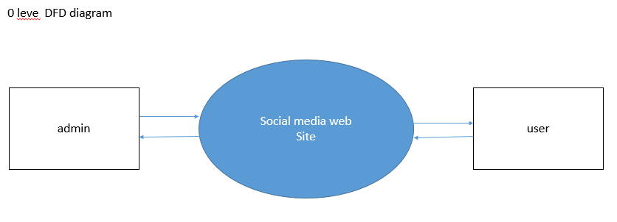

* 1 Level DFD Diagram

1. Hear in 1 level DFD diagram define interaction of user with each page and define request of user to database and vise versa.
2. Here user first user sign in and registration it self user and send data to user database.
3. Next it can also access database to enter in site so database response if user is valid.
4. After it access home page, profile page, message page, privacy page, game zone.
5. And logout click than session of user remove and it automatic redirect in login page.
6. Main database is user database other data base are also interact the main database.

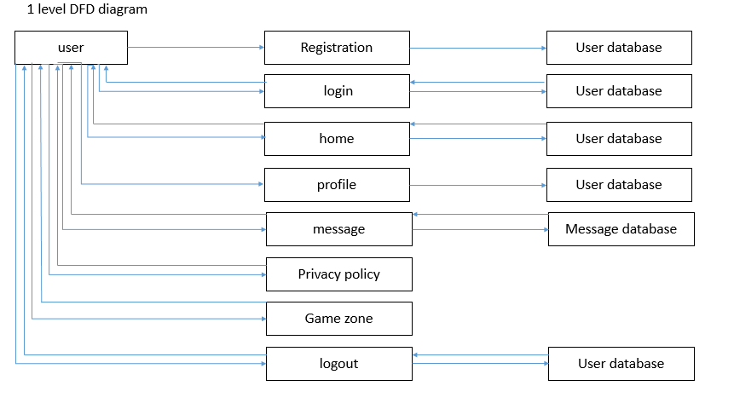

* 2 level DFD Digaram

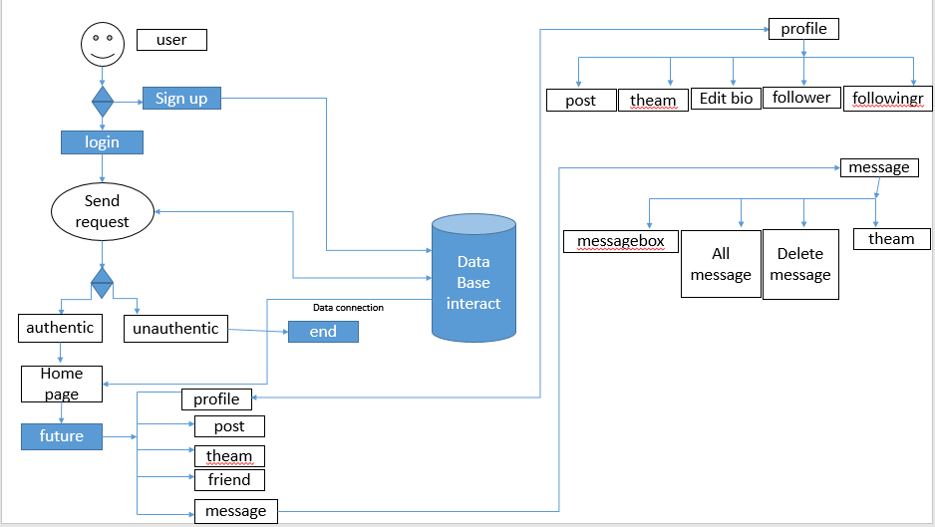

* Class diagram
* n software engineering, a class diagram in the [**Unified Modeling Language (UML)**](https://en.wikipedia.org/wiki/Unified_Modeling_Language) is **a type of static structure diagram** that describes the structure of a system by showing the system's classes, their attributes, operations (or methods), and the relationships among objects.
* Shows static structure of classifiers in a system
* Diagram provides a basic notation for other structure diagrams prescribed by UML
* Helpful for developers and other team members too
* Business Analysts can use class diagrams to model systems from a business perspective

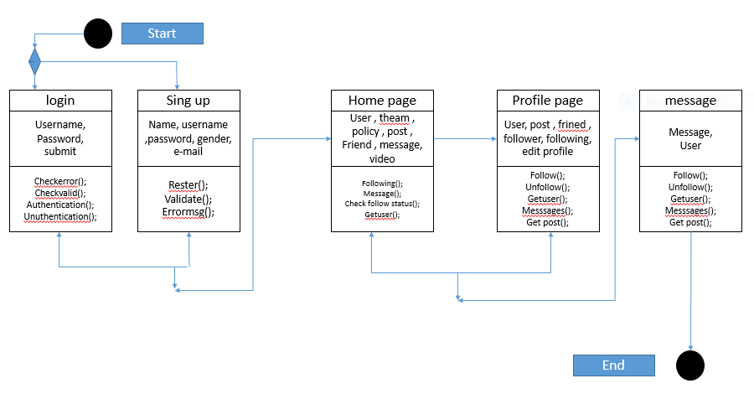

* Activity diagram
* The basic purposes of activity diagrams is similar to other four diagrams. It captures the dynamic behavior of the system. Other four diagrams are used to show the message flow from one object to another but activity diagram is used to show message flow from one activity to another.
* Activity is a particular operation of the system. Activity diagrams are not only used for visualizing the dynamic nature of a system, but they are also used to construct the executable system by using forward and reverse engineering techniques. The only missing thing in the activity diagram is the message part.
* It does not show any message flow from one activity to another. Activity diagram is sometimes considered as the flowchart. Although the diagrams look like a flowchart, they are not. It shows different flows such as parallel, branched, concurrent, and single

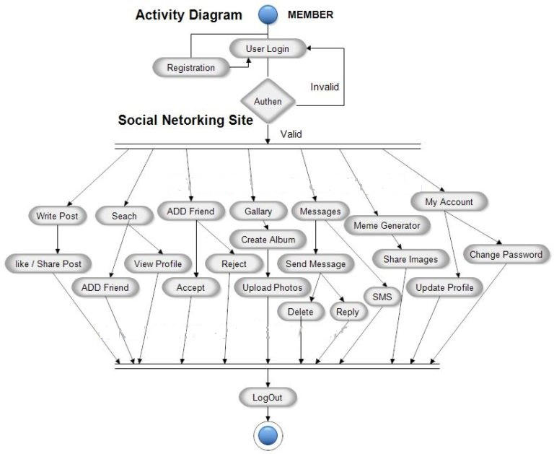

* E R diagram
* An Entity Relationship (ER) Diagram is a type of flowchart that illustrates how “entities” such as people, objects or concepts relate to each other within a system. ER Diagrams are most often used to design or debug relational databases in the fields of software engineering, business information systems, education and research. Also known as ERDs or ER Models, they use a defined set of symbols such as rectangles, diamonds, ovals and connecting lines to depict the interconnectedness of entities, relationships and their attributes. They mirror grammatical structure, with entities as nouns and relationships as verbs.
* ER diagrams are related to data structure diagrams (DSDs), which focus on the relationships of elements within entities instead of relationships between entities themselves. ER diagrams also are often used in conjunction with data flow diagrams (DFDs), which map out the flow of information for processes or systems.

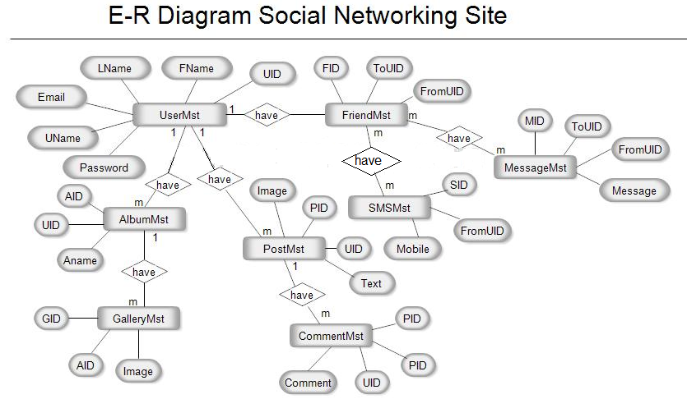

* use case diagram

A use case diagram is used to represent the dynamic behavior of a system. It encapsulates the system's functionality by incorporating use cases, actors, and their relationships. It models the tasks, services, and functions required by a system/subsystem of an application. It depicts the high-level functionality of a system and also tells how the user handles a system.

## **Purpose of Use Case Diagrams**

The main purpose of a use case diagram is to portray the dynamic aspect of a system. It accumulates the system's requirement, which includes both internal as well as external influences. It invokes persons, use cases, and several things that invoke the actors and elements accountable for the implementation of use case diagrams. It represents how an entity from the external environment can interact with a part of the system.

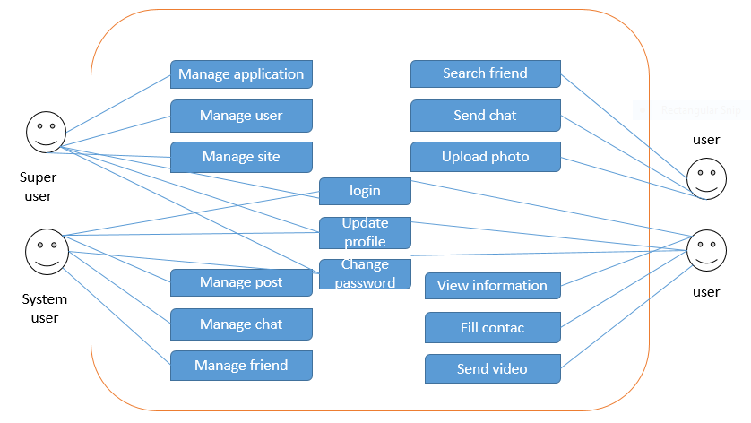

|  |
| --- |
| 3.2 Data Dictionary |
| 3.2.1 List all database table with description     * User table 1 |
|  |
| * + - User table2 |

* Posts

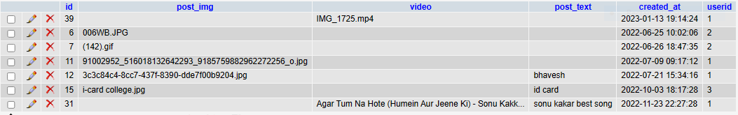

* Messages

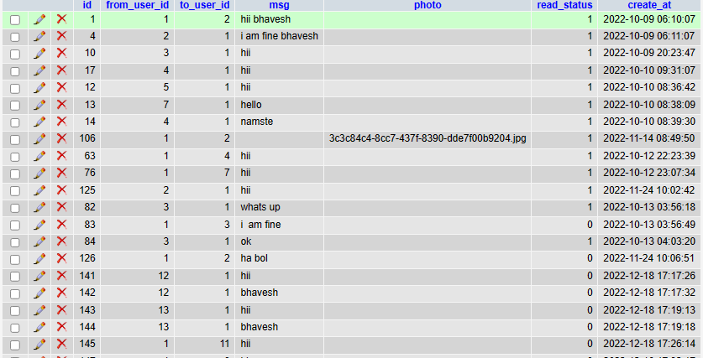

* Likes

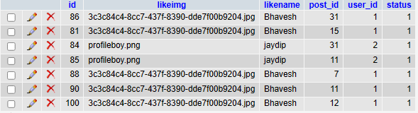

* Follow_list

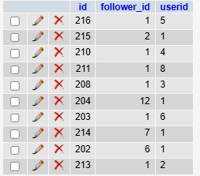

* Post-msg

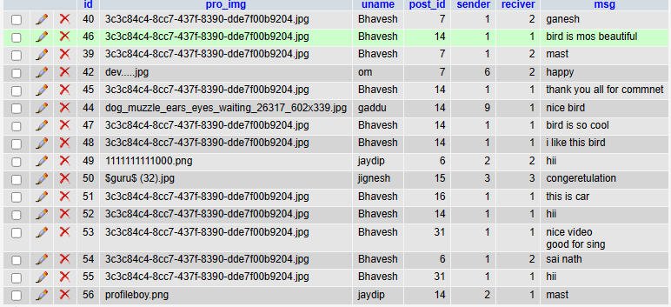

* admin

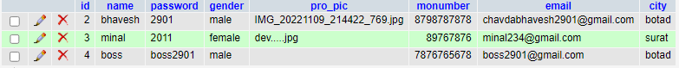

3.3 Input/Output Design

## **Input Design**

In an information system, input is the raw data that is processed to produce output. During the input design, the developers must consider the input devices such as PC, MICR, OMR, etc.

Therefore, the quality of system input determines the quality of system output. Welldesigned input forms and screens have following properties −

* It should serve specific purpose effectively such as storing, recording, and retrieving the information.
* It ensures proper completion with accuracy.
* It should be easy to fill and straightforward.
* It should focus on user’s attention, consistency, and simplicity.
* All these objectives are obtained using the knowledge of basic design principles regarding −
  + What are the inputs needed for the system?
  + How end users respond to different elements of forms and screens.

### Objectives for Input Design

* To design data entry and input procedures
* To reduce input volume
* To design source documents for data capture or devise other data capture methods
* To design input data records, data entry screens, user interface screens, etc.
* To use validation checks and develop effective input controls.

### Data Input Methods

It is important to design appropriate data input methods to prevent errors while entering data. These methods depend on whether the data is entered by customers in forms manually and later entered by data entry operators, or data is directly entered by users on the PCs.

A system should prevent user from making mistakes by −

* Clear form design by leaving enough space for writing legibly.
* Clear instructions to fill form.
* Clear form design.
* Reducing key strokes.

### Input Integrity Controls

Input integrity controls include a number of methods to eliminate common input errors by end-users. They also include checks on the value of individual fields; both for format and the completeness of all inputs.

Audit trails for data entry and other system operations are created using transaction logs which gives a record of all changes introduced in the database to provide security and means of recovery in case of any failure.

## **Output Design**

The design of output is the most important task of any system. During output design, developers identify the type of outputs needed, and consider the necessary output controls and prototype report layouts.

### Objectives of Output Design

The objectives of input design are −

* To develop output design that serves the intended purpose and eliminates the production of unwanted output.
* To develop the output design that meets the end users requirements.
* To deliver the appropriate quantity of output.
* To form the output in appropriate format and direct it to the right person.
* To make the output available on time for making good decisions.

Let us now go through various types of outputs –

### External Outputs

Manufacturers create and design external outputs for printers. External outputs enable the system to leave the trigger actions on the part of their recipients or confirm actions to their recipients.

Some of the external outputs are designed as turnaround outputs, which are implemented as a form and re-enter the system as an input.

* Login Page
* This is page that we login user hear .
* Some option are also available like change password and sign up user.

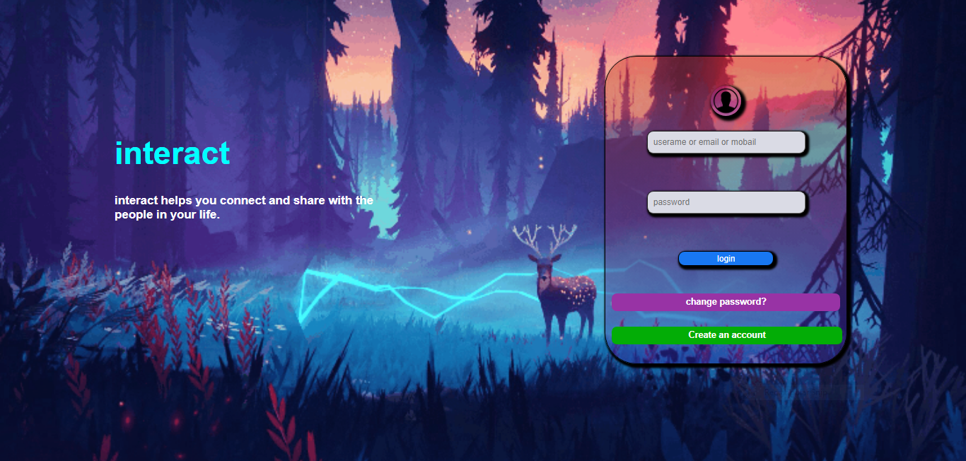

* This page of sign up in this page user can register it’s self
* When we click create account than signup pop open

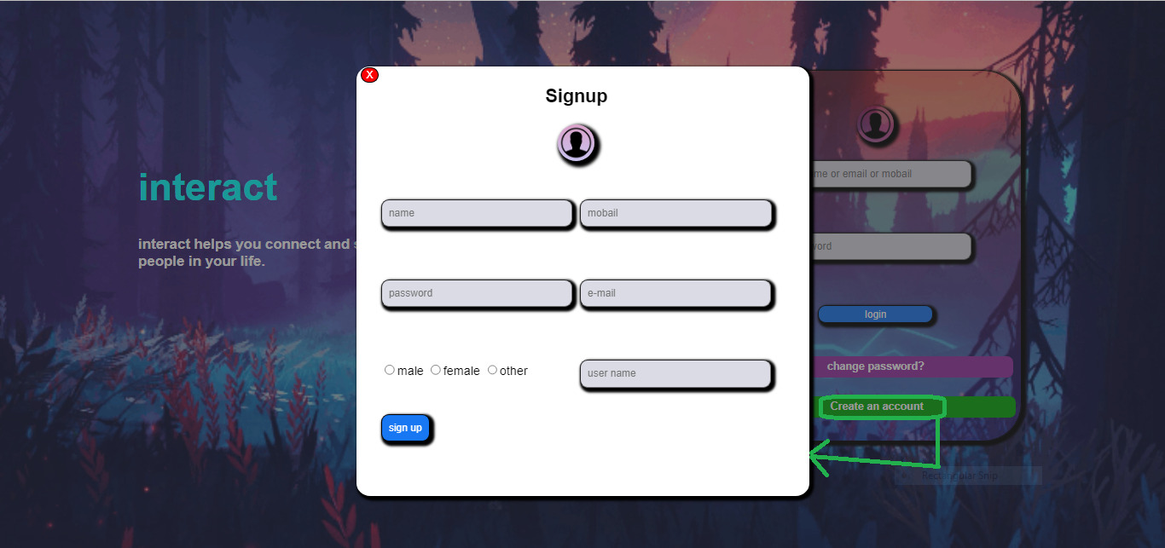

* Change password pop section
* In this section pop open when click change password button .

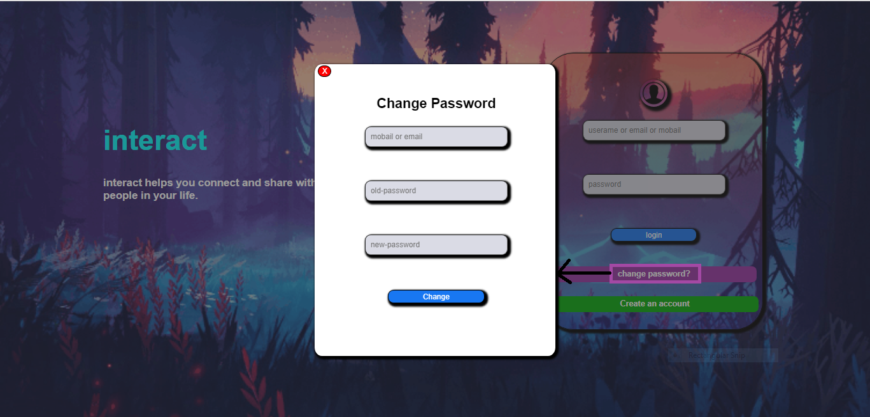

* Loader ( loading paging ):

This section loader when we login and authenticate than automatically it redirect loader after process done than it redirect home page.

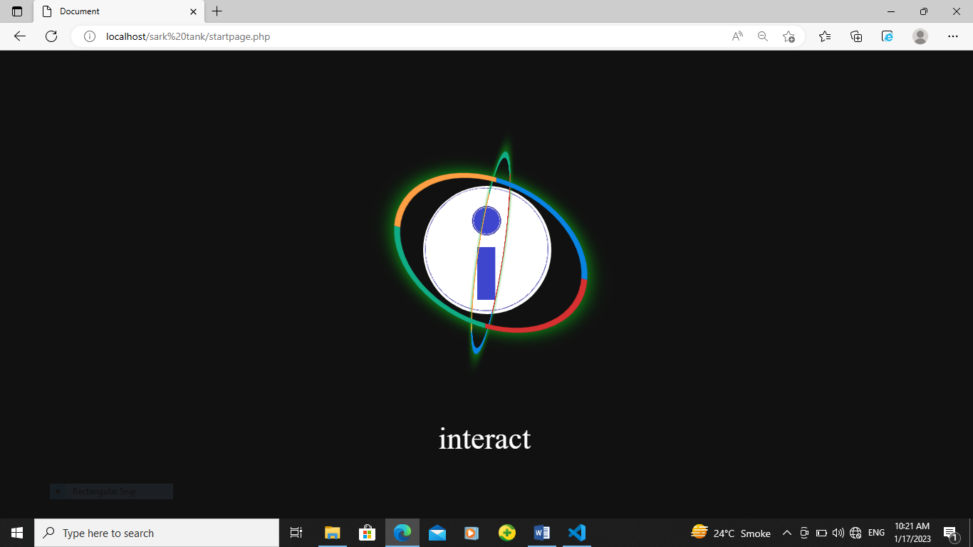

* Home page

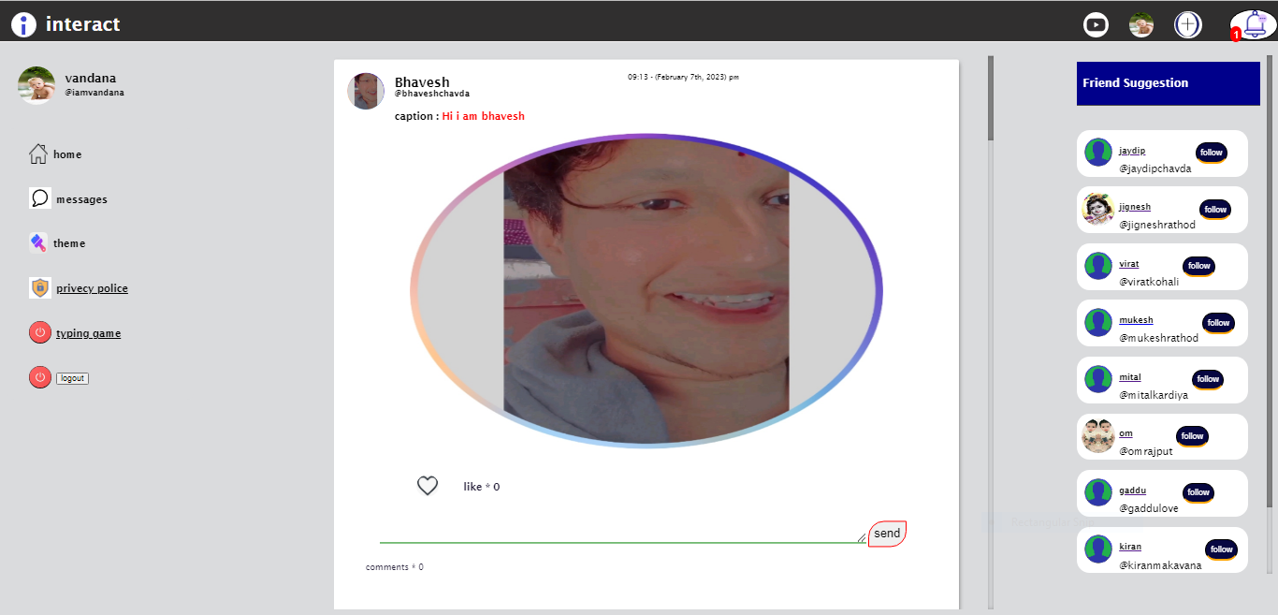

* Post video

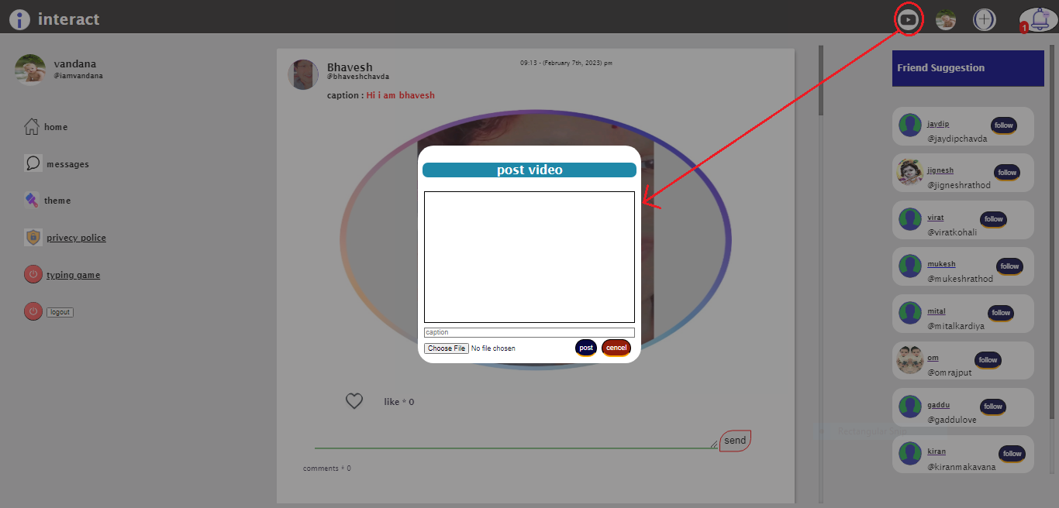

* Notification bar

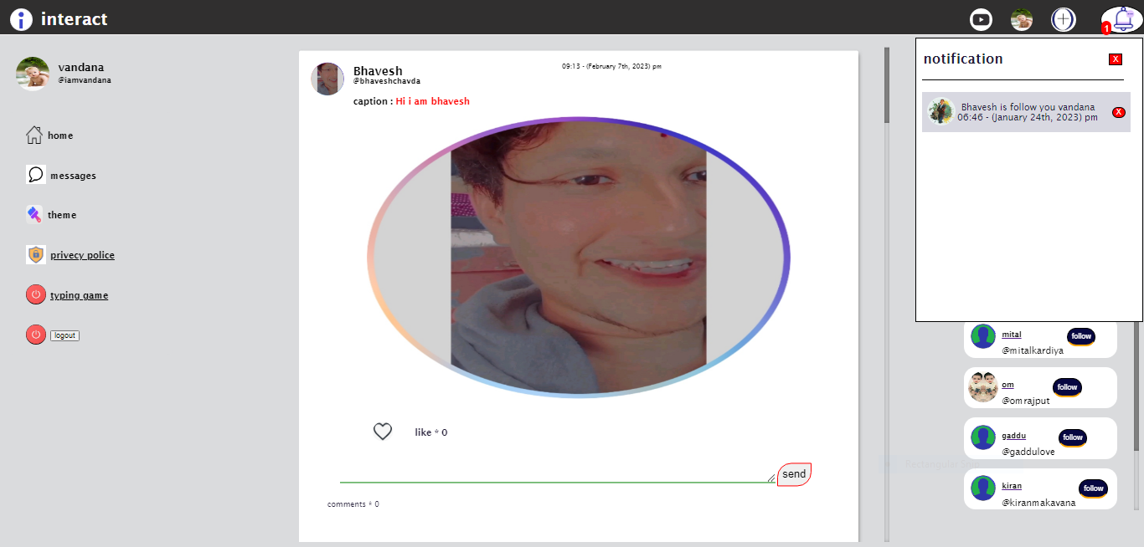

* Messages box

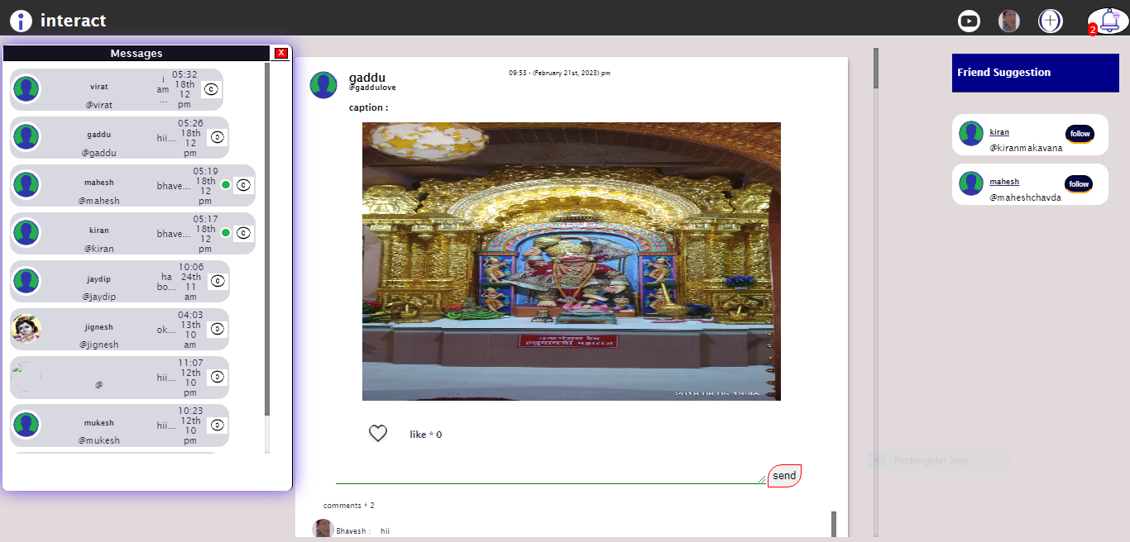

* Post pop-up

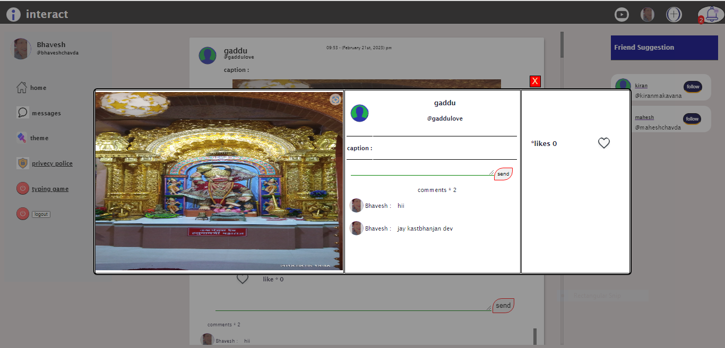

* Home theam

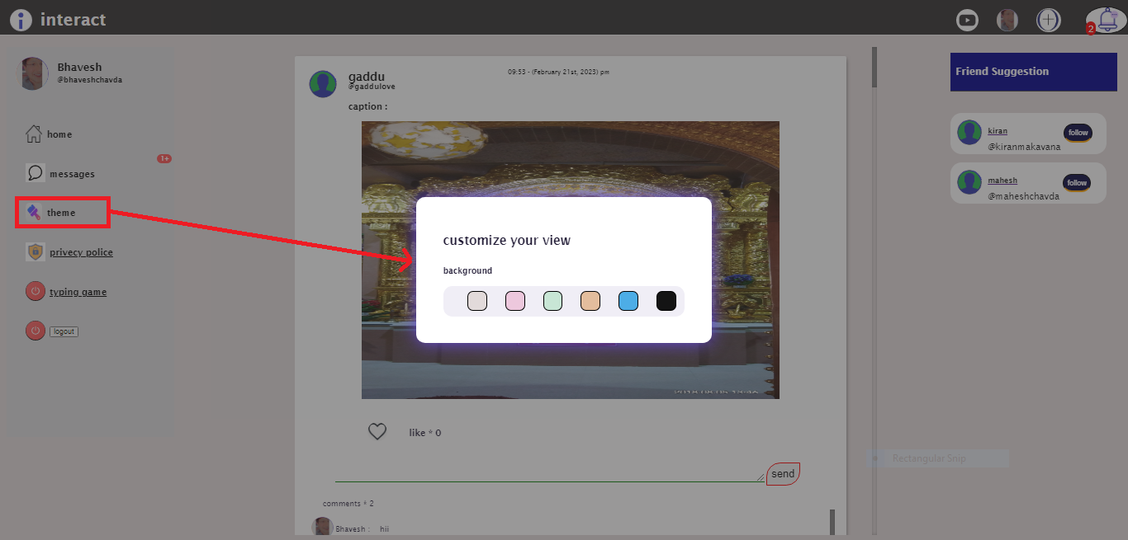

* Profile page

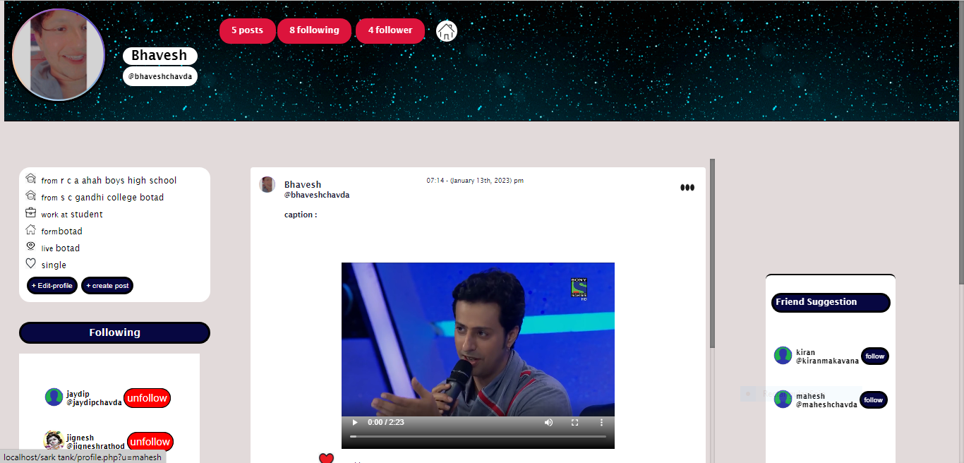

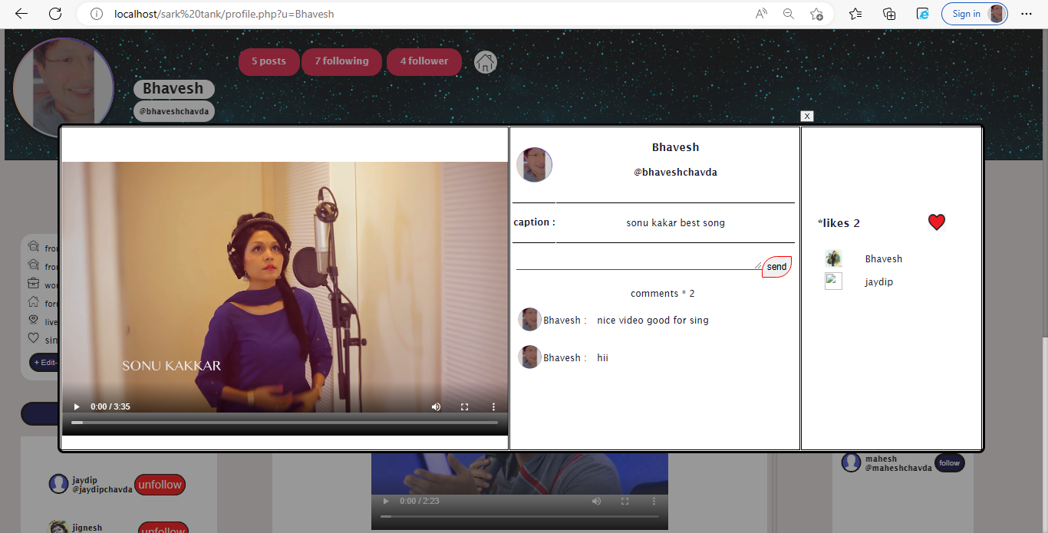

* Following pop-up

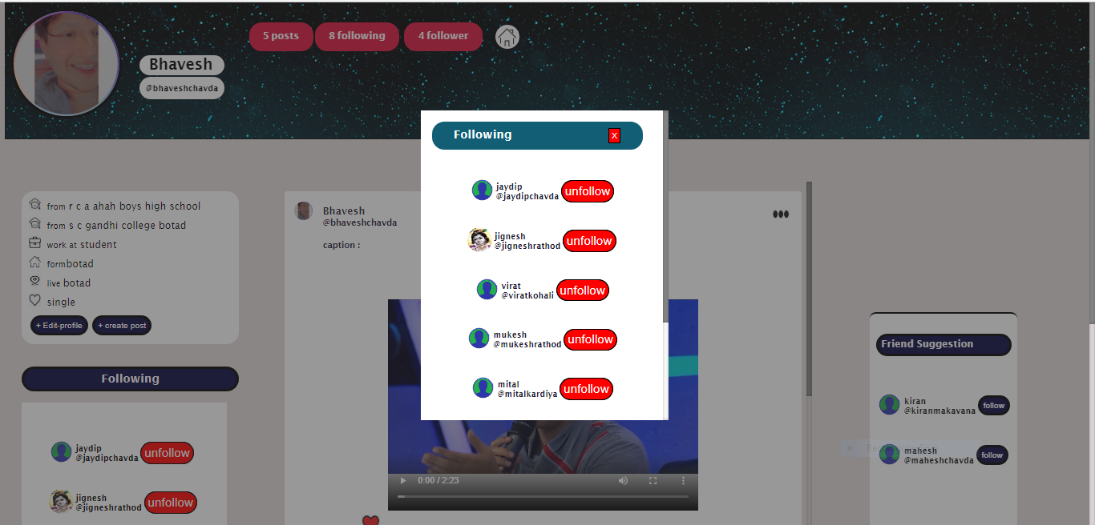

* Edit profile

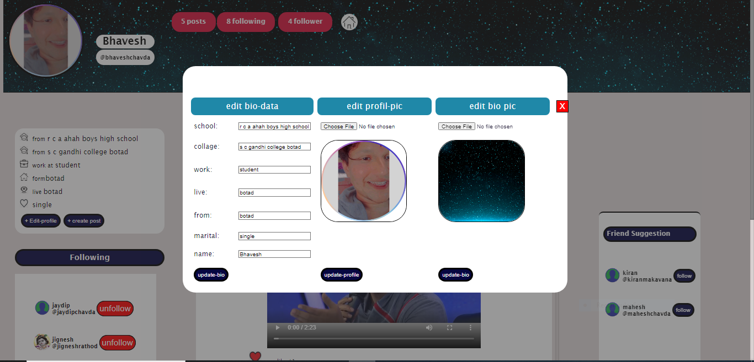

* Pop profile pic

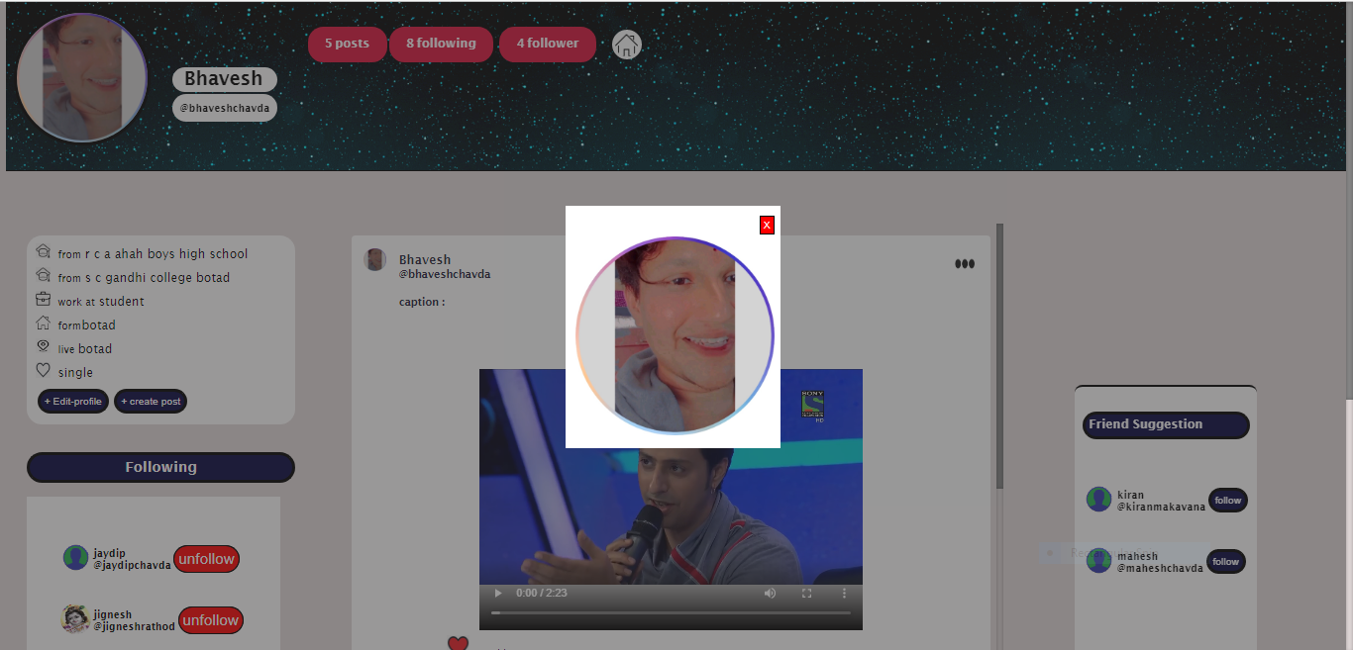

* Massenger

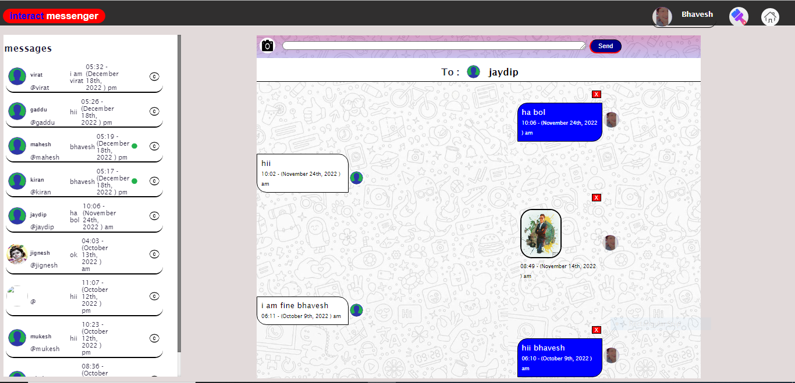

* Theam pop-up

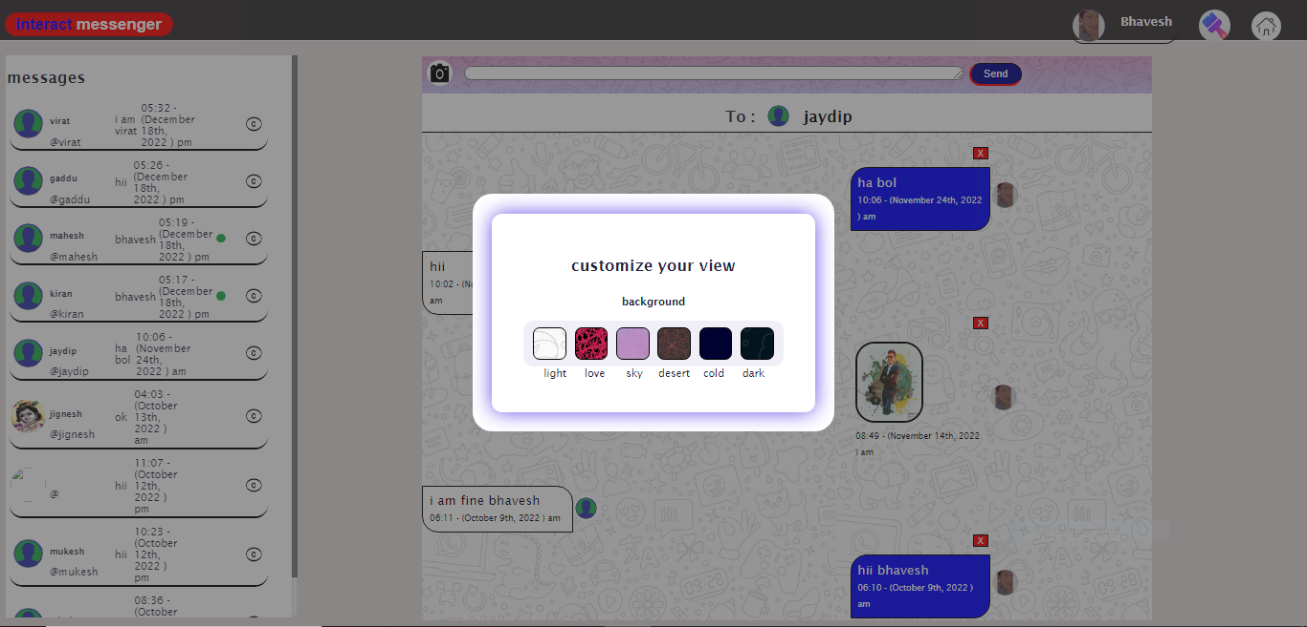

* Theam message

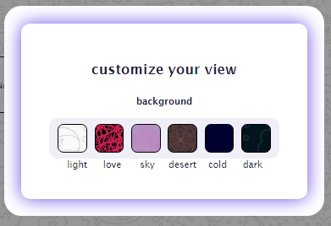

Love theam

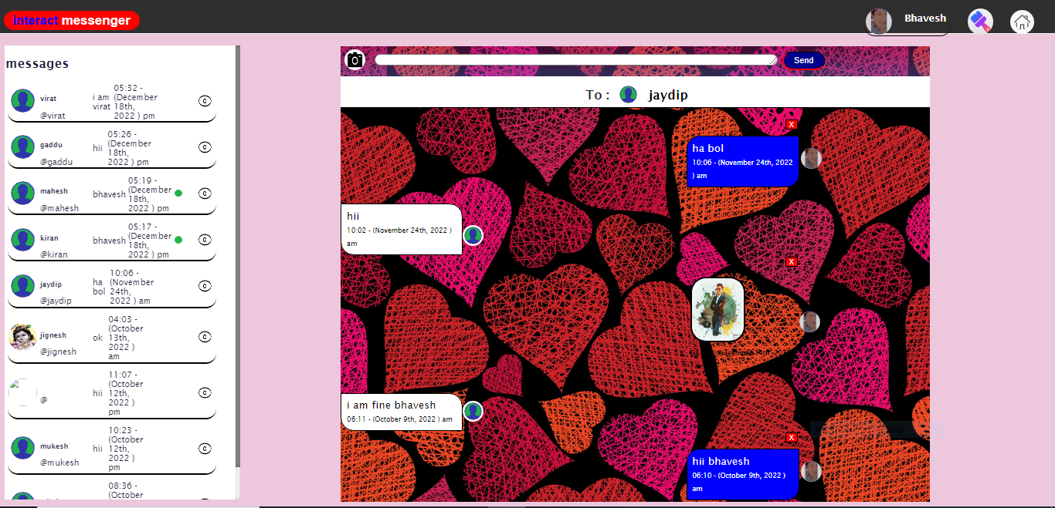

Sky theam

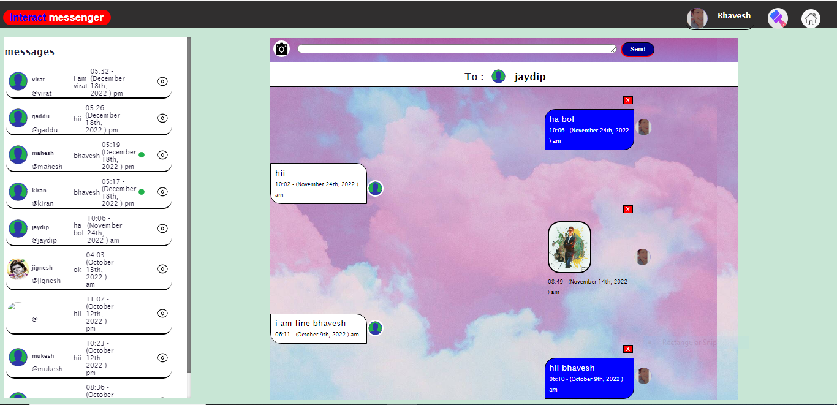

Desert

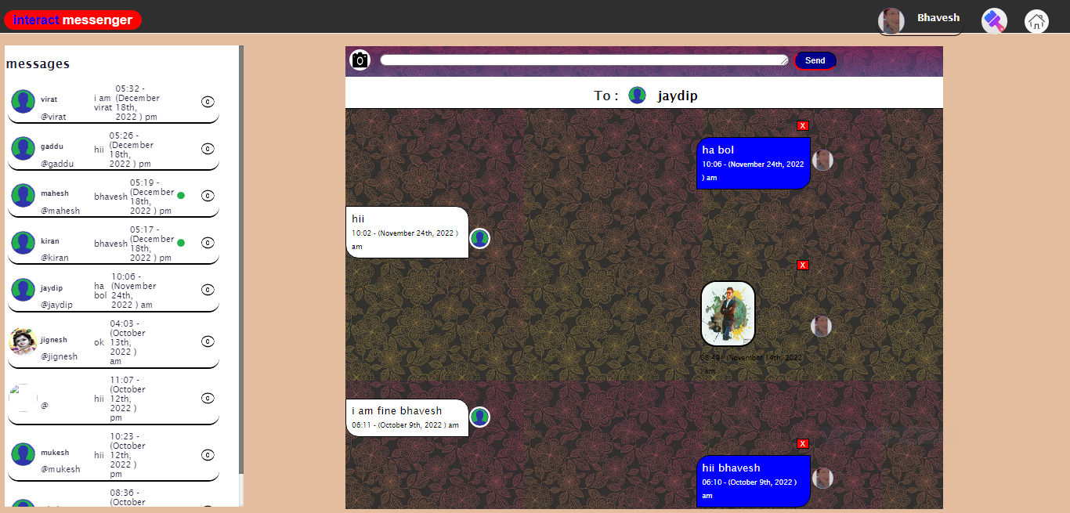

Cold theam

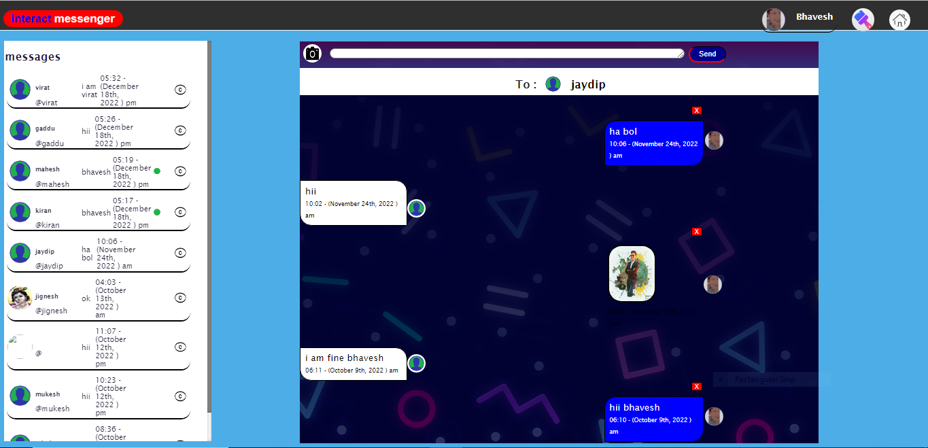

Dark theam

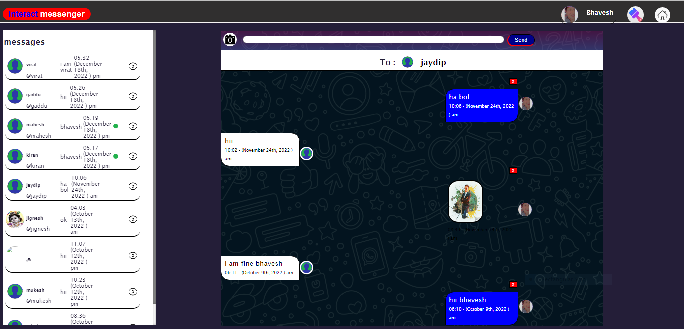

* Admin login

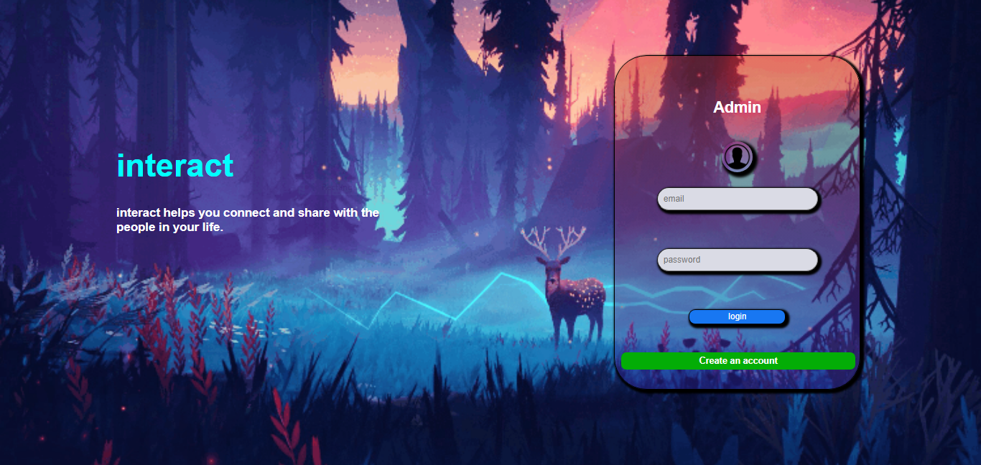

* Admin

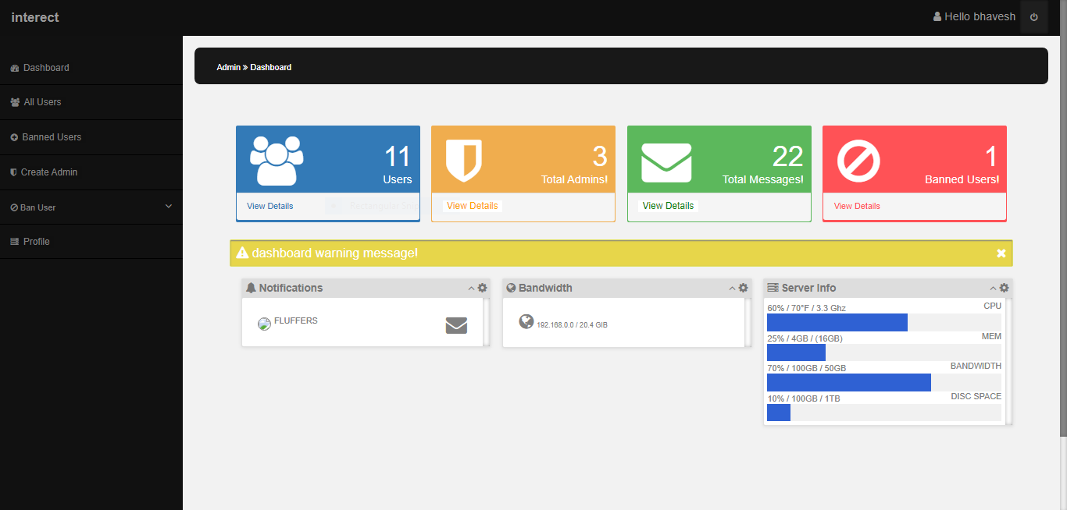

* Admin >> all user

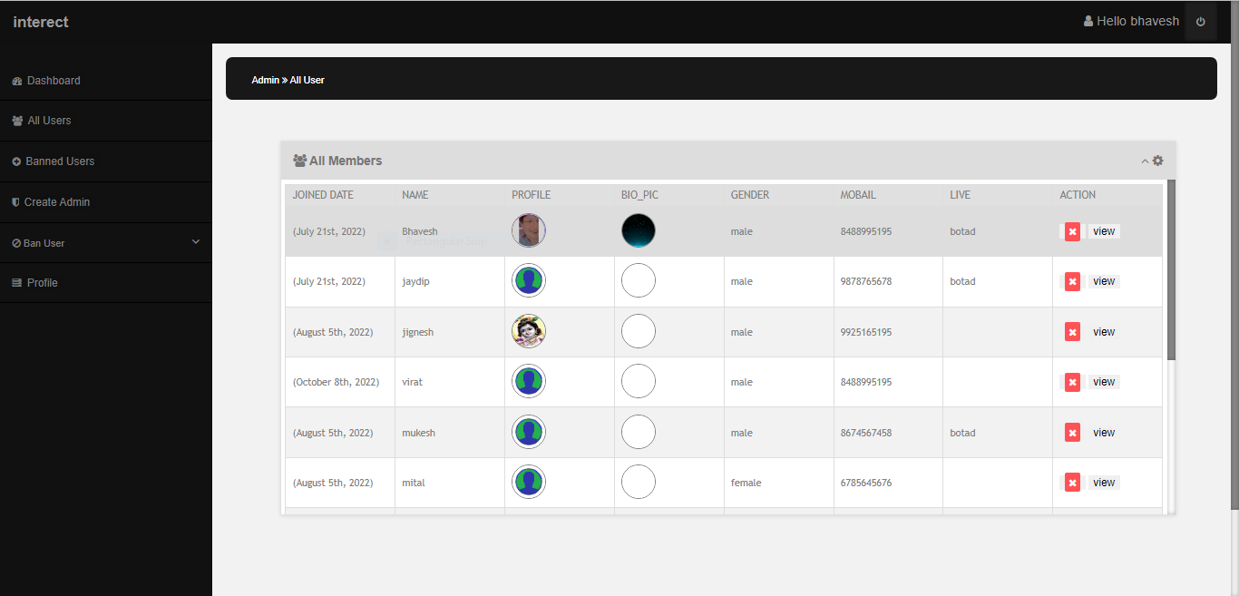

* All user detail

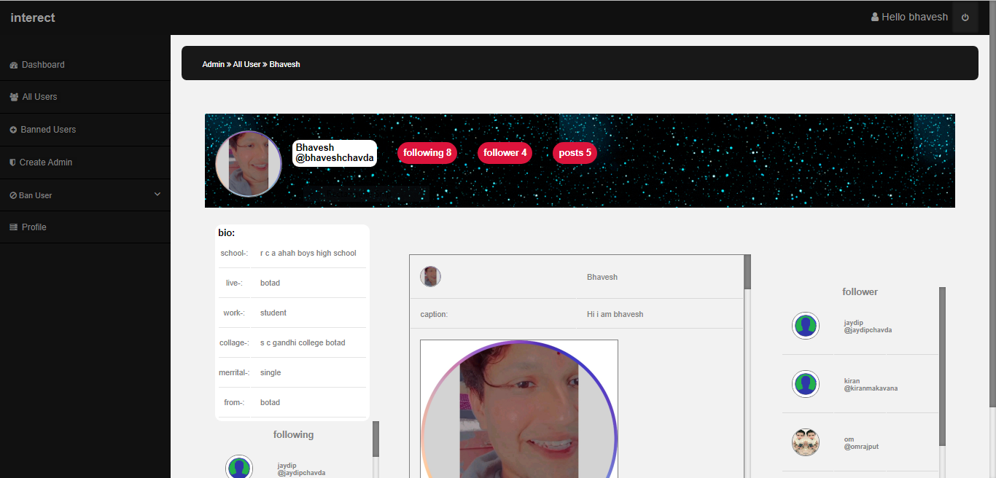

* Banned user

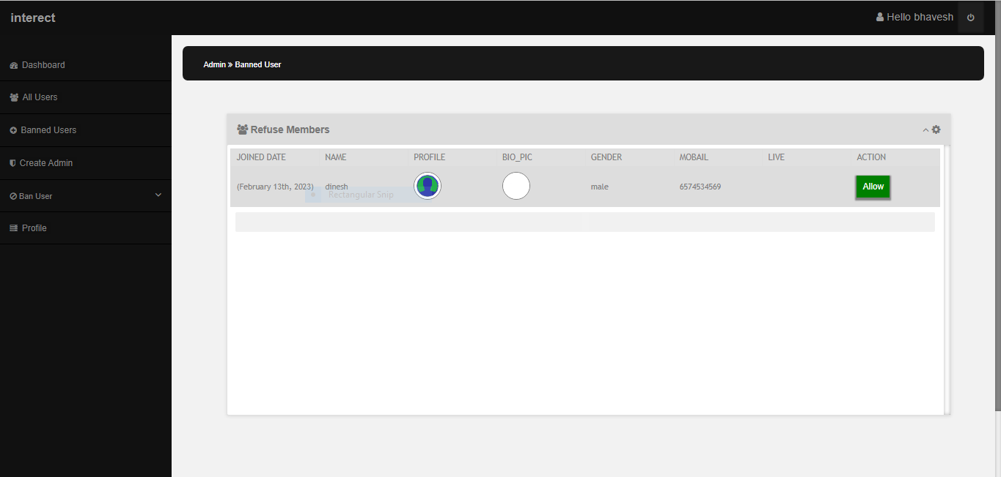

* Admin create

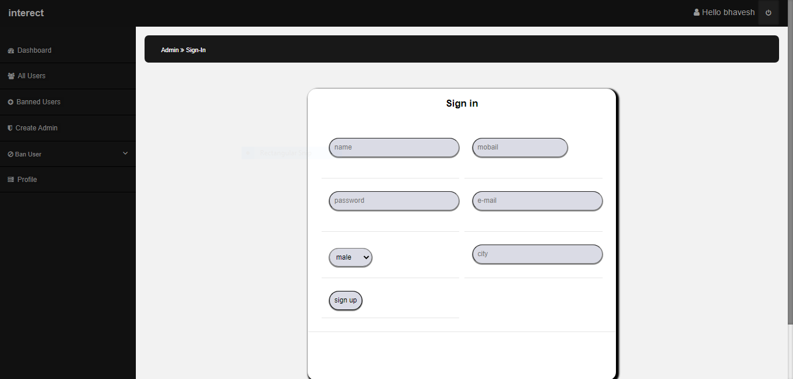

* Admin profile edit

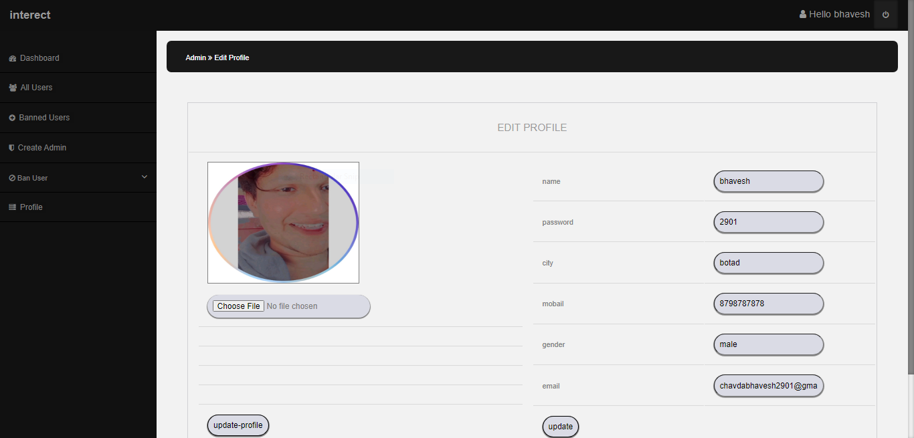

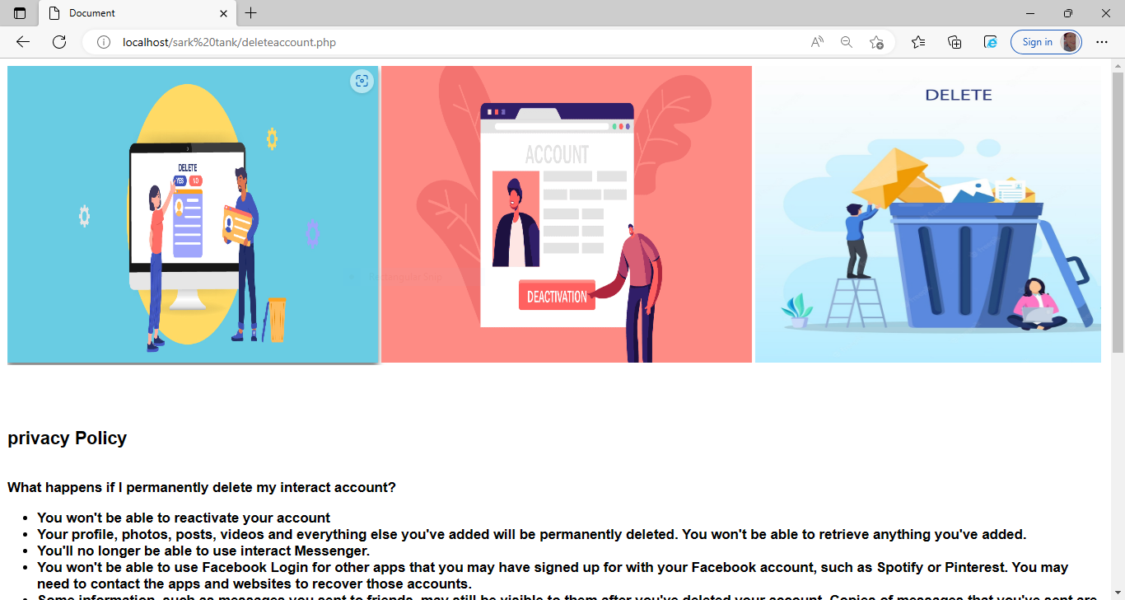

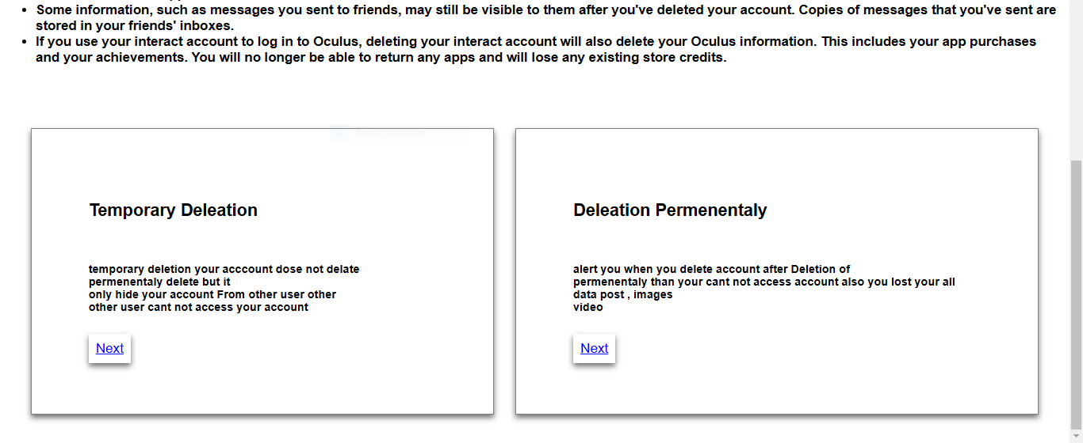

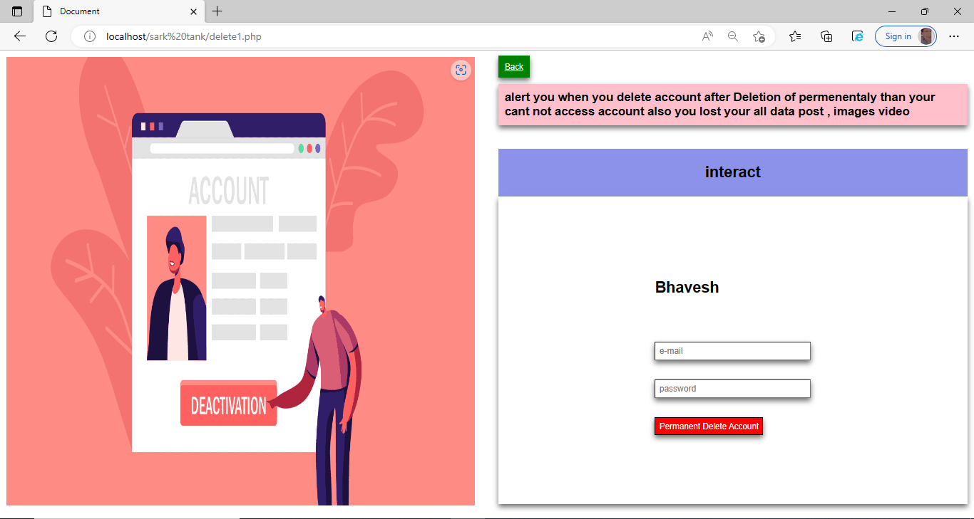

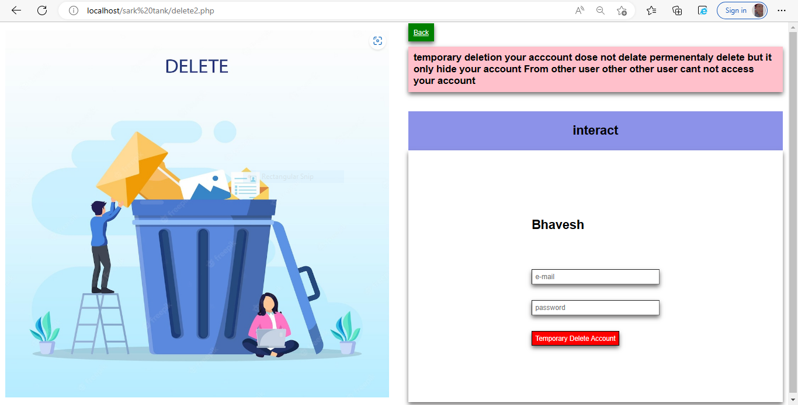

|  |
| --- |
| 4 Testing and implementation |
| 4.1 Testing and Approaches |
| 4.1.1 unit Testing |
| 4.1.2 performance Testing |
| 4.1.3 system testing |
| 4.1.1 back-end testing |
| 4.1.2 White box testing |
| 4.2 test cases |
| 4.3 Implementation Approaches |
| `````4.3.1 parallel Approach |
| 4.3.2 phased approches |
| 4.3.3 waterfall approches |
| 4.3.4 Spiral Model |

Unit 4 Testing and implementation

**Unit Testing :**

**Unit Testing** is a software testing technique by means of which individual units of software i.e. group of computer program modules, usage procedures, and operating procedures are tested to determine whether they are suitable for use or not. It is a testing method using which every independent module is tested to determine if there is an issue by the developer himself. It is correlated with the functional correctness of the independent modules. Unit Testing is defined as a type of software testing where individual components of a software are tested. Unit Testing of the software product is carried out during the development of an application. An individual component may be either an individual function or a procedure. Unit Testing is typically performed by the developer. In SDLC or V Model, Unit testing is the first level of testing done before integration testing. Unit testing is such a type of testing technique that is usually performed by developers. Although due to the reluctance of developers to test, quality assurance engineers also do unit testing.

**Objective of Unit Testing:**

The objective of Unit Testing is:

1. To isolate a section of code.
2. To verify the correctness of the code.
3. To test every function and procedure.
4. To fix bugs early in the development cycle and to save costs.
5. To help the developers to understand the code base and enable them to make changes quickly.
6. To help with code reuse.

# performance testing

Performance testing is a testing measure that evaluates the speed, responsiveness and stability of a computer, network, software program or device under a workload. Organizations will run performance tests in order to identify performance-related [bottlenecks](https://www.techtarget.com/searchnetworking/definition/bottleneck).

Without some form of performance testing in place, system performance will likely be affected with slow response times, experiences that are inconsistent between users and the operating system, creating an overall poor user experience. Determining if the developed system meets speed, responsiveness and stability requirements while under workloads will help ensure a more positive user experience.

Performance testing can involve quantitative tests done in a lab, or in some scenarios, occur in the production environment. Performance [requirements should be identified](https://www.techtarget.com/searchsoftwarequality/answer/Required-prerequisites-for-performance-testing) and tested. Typical parameters include processing speed, data transfer rates, network [bandwidth](https://www.techtarget.com/searchnetworking/definition/bandwidth) and [throughput](https://www.techtarget.com/searchnetworking/definition/throughput), workload efficiency and reliability. As an example, an organization can measure the response time of a program when a user requests an action; the same can be done at scale. If the response times are so slow that it would annoy end users, then this means it should be tested to find where the bottleneck is.

### Why use performance testing?

An organization can use performance testing as a diagnostic aid to locate computing or communications bottlenecks within a system. Bottlenecks are a single point or component within a system's overall function that holds back overall performance. For example, even the fastest computer will function poorly on the web if the bandwidth is less than 1 megabit per second ([Mbps](https://www.techtarget.com/searchnetworking/definition/Mbps)). Slow data transfer rates might be inherent in hardware but could also result from software-related problems -- such as too many applications running at the same time or a corrupted file in a web browser.

## What is System Testing?

**System Testing** is a level of testing that validates the complete and fully integrated software product. The purpose of a system test is to evaluate the end-to-end system specifications. Usually, the software is only one element of a larger computer-based system. Ultimately, the software is interfaced with other software/hardware systems. System Testing is defined as a series of different tests whose sole purpose is to exercise the full computer-based system.

Two Category of Software Testing

* Black Box Testing
* White Box Testing

## Black Box Testing

**Black Box Testing** is a software testing method in which the functionalities of software applications are tested without having knowledge of internal code structure, implementation details and internal paths. Black Box Testing mainly focuses on input and output of software applications and it is entirely based on software requirements and specifications. It is also known as Behavioral Testing.

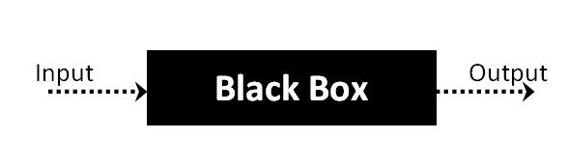

## How to do BlackBox Testing

Here are the generic steps followed to carry out any type of Black Box Testing.

* Initially, the requirements and specifications of the system are examined.
* Tester chooses valid inputs (positive test scenario) to check whether SUT processes them correctly. Also, some invalid inputs (negative test scenario) are chosen to verify that the SUT is able to detect them.
* Tester determines expected outputs for all those inputs.
* Software tester constructs test cases with the selected inputs.
* The test cases are executed.
* Software tester compares the actual outputs with the expected outputs.
* Defects if any are fixed and re-tested.
* Type of black box testing
* **Functional testing** – This black box testing type is related to the functional requirements of a system; it is done by software testers.
* **Non-functional testing**– This type of black box testing is not related to testing of specific functionality, but non-functional requirements such as performance, scalability, usability.
* **White box testing**

**White box testing** techniques analyze the internal structures the used data structures, internal design, code structure, and the working of the software rather than just the functionality as in black box testing. It is also called glass box testing or clear box testing or structural testing. White Box Testing is also known as transparent testing, open box testing.

**Working process of white box testing:**

* **Input:** Requirements, Functional specifications, design documents, source code.
* **Processing:** Performing risk analysis for guiding through the entire process.
* **Proper test planning:** Designing test cases so as to cover the entire code. Execute rinse-repeat until error-free software is reached. Also, the results are communicated.
* **Output:** Preparing final report of the entire testing process.

**Testing techniques:**

* **Statement coverage:** In this technique, the aim is to traverse all statement at least once. Hence, each line of code is tested. In case of a flowchart, every node must be traversed at least once. Since all lines of code are covered, helps in pointing out faulty code.
* **Branch Coverage:** In this technique, test cases are designed so that each branch from all decision points are traversed at least once. In a flowchart, all edges must be traversed at least once.
* **Basis Path Testing:** In this technique, control flow graphs are made from code or flowchart and then Cyclomatic complexity is calculated which defines the number of independent paths so that the minimal number of test cases can be designed for each independent path
* **Loop Testing:** Loops are widely used and these are fundamental to many algorithms hence, their testing is very important. Errors often occur at the beginnings and ends of loops.

## Test Cases For Social Media

* Similar Test Cases
* Test Case For Search Box
* Test Case For Search Filter
* Test Case For Search Functionality
* Test Case For Text Area
* Test Case For Text Field
* Test Case For Textbox
* **Comment Block**
* Check if the user is able to comment on the comment block.
* Check if the user can like it as well as reply to the comments entered by other users.
* Check if the recent comments are getting displayed on the top of the block.
* Check if the user is able to delete/edit the entered comments.

### Media Transfer

Media transfer is a vital aspect of a social app. Transmitting media in its original, uncompressed form is cost-prohibitive, as it requires gigabytes of bandwidth and is more time-consuming.

For a social app, data quality is compromised to some extent because digital media content is compressed prior to transmission. There is partial data loss every time that digital content is shared further, but this is barely noticeable. Moreover, the ease of transmission, storage, and retrieval of this data more than makes up for the infinitesimal loss of data quality.

### Load Testing

For load testing, two factors are vital from the QA perspective: speed and user load. To test these aspects, my team used API tools where they specified the load and the expected response time in the API calls, then verified the results from the responses.

Let’s say we have to test for media transfer between a thousand users in ten seconds. We will need to run a thousand API calls—this is where the API test tool helps. From the results of these API calls, we can work out the average response time, basing it also on the type of data being transmitted: text, image, or video.

Implementation Approaches

# Parallel approach

Before taking a toll on Parallel Computing, first, let’s take a look at the background of computations of computer software and why it failed for the modern era.

Computer software was written conventionally for serial computing. This meant that to solve a problem, an algorithm divides the problem into smaller instructions. These discrete instructions are then executed on the Central Processing Unit of a computer one by one. Only after one instruction is finished, next one starts.

A real-life example of this would be people standing in a queue waiting for a movie ticket and there is only a cashier. The cashier is giving tickets one by one to the persons. The complexity of this situation increases when there are 2 queues and only one cashier.

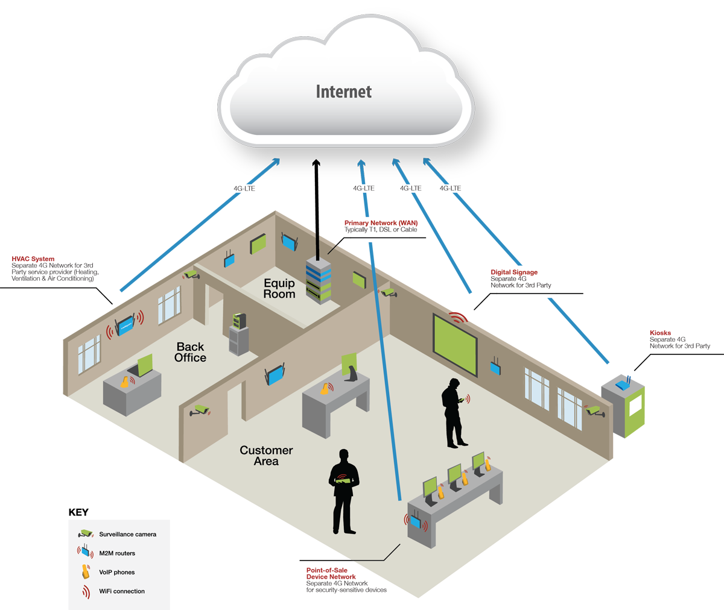

**Waterfall model definition:**

The waterfall model is a sequential design process, often used in [software development processes](http://en.wikipedia.org/wiki/Software_development_process), where progress is seen as flowing steadily downwards (like a waterfall) through the phases of Conception, Initiation, Analysis, Design, Construction, Testing, Production/Implementation, and Maintenance.

This model is also called the **Classic life cycle model** as it suggests a systematic sequential approach to software development. This one of the oldest models followed in software engineering.

The process begins with the communication phase where the customer specifies the requirements and then progress through other phases of **planning, modeling, construction, and deployment** of the software.

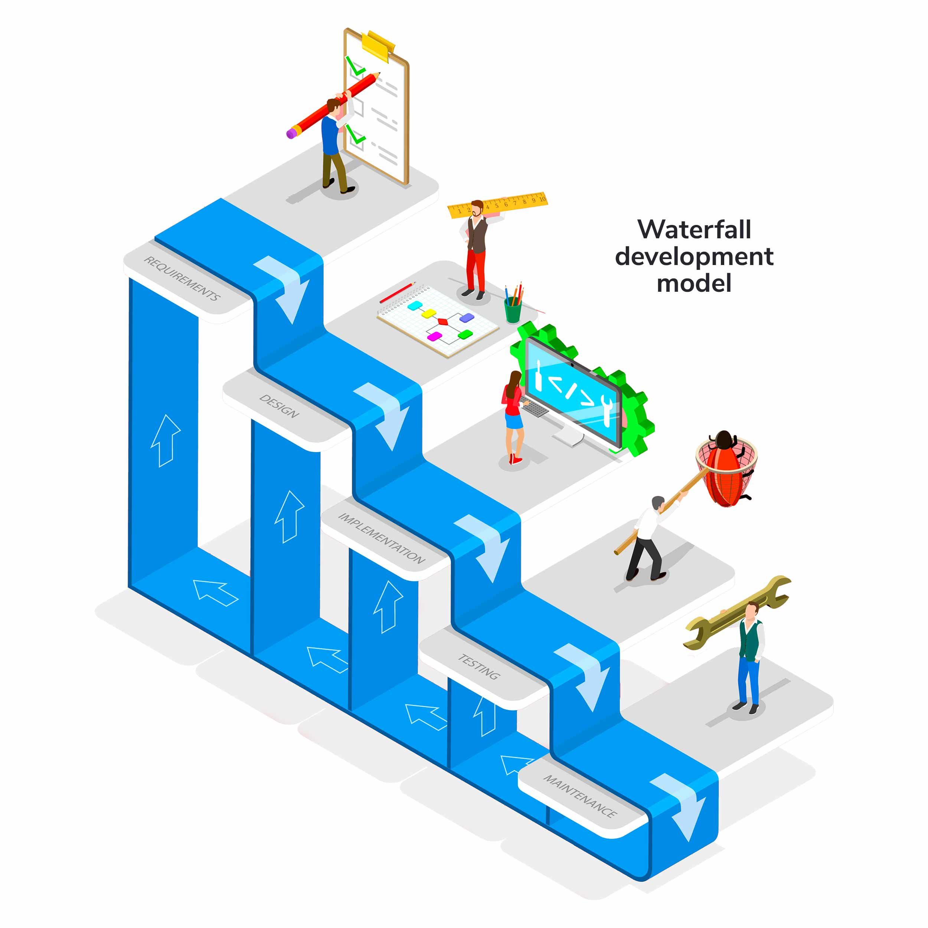

# Spiral Model in Software Engineering

## Introduction

The spiral model is a risk-based software development approach. The spiral model guides a team to adopt components of one or more process models, such as incremental, waterfall, or evolutionary prototyping, based on the particular risk patterns of a given project.

The spiral model is one of the best software development life cycle models due to the following properties:

* Risk management is present in the model.
* The Spiral model is also popular due to its ability to adapt to changes.
* Frequent feedback from the client.

## Scope

* This article will help us learn about what is the spiral model and the different phases of the spiral model
* We will see when to use the spiral model and the advantages and disadvantages of the model
* We will also be learning about risk handling in the spiral model

## What is the Spiral Model?

It is an evolutionary process model that combines prototyping's iterative nature with the linear sequential model's regulated and systematic characteristics. It implements the capability of rapid production of new software versions. The program is developed in a series of incremental releases using the spiral methodology.

The spiral model is one of the most prominent Software Development Life Cycle models for risk management. It resembles a spiral with several loops in diagrammatic depiction. The spiral's exact number of loops is unclear, and it varies from project to project.

|  |
| --- |
| 5. Conclusion |
| 5.1 Limitation of System |
| 5.2 Future Scope of system |
| 5.3 Bibliography |
| 5.4 Webliography |

Unit 5 Conclusion

* 5.1 Limitation of System

In this site some limitation of system that is following bellow I can try my best to find this best solution in feature.

* 1. Fist limitation of system is user interface problem some time user can not understand what we say in this.
  2. This web site not able open mobile because it not responsive it only responsive in laptop
  3. Some time it load when more data store in database.
  4. Some new feature like video call not available in this site.
  5. In this site you can not block user because this site specially make for interaction of people.
  6. It is refresh page each time so that it load many time .
  7. We cant not see like who like the post or video .
  8. Some user interface problem in site it can feature develop.

* 5.2 Future Scope of system
* This is the age of contacts for interaction between people to people through social platforms in the web. The tremendous popularity of using the social media networking could never have been realized before. In fact, social media have become an important tool of marketing in true sense of customer orientation. The scope of social networking is widening, and today it offers a strong support to the companies in providing the much desired touch of concern. Future of social media networking brings exciting promises as expected from the experience of limited users from a few companies in the top bracket.
* This is the beginning of interweaving social media networking as a positive business process bringing two people together than merely two organizational entities. People can communicate their message to the suppliers or customers and also convey any difference of opinion over the social networks. The business community has started to take a keen interest in the enormous possibilities of reaching and serving the buyers in this emerging domain of marketing.
* Social media networking is a more practical approach for dealing with the consumers. It may be for improving the products listening to the customers’ views with critical appreciations. It may also help improving the ways of dealing with buyers using them as ears and the eye of the organizations.  All the big companies are quite optimistic about the positive impact of Social media networking and gone into developing fully integrated processed with a holistic touch.  Take the example of activities the companies like IBM, Microsoft and Google performs to strengthen their networking platforms via social networks like Twitter and Facebook.
* The bright future prospect of social networking is also proven with the fact that the technology is integrated in the mobile phones as well. Look at the devices designed with powers of interpersonal communication on a globalized outlook. These devices are now being created to with the perspective of global interaction and messaging across geographical boundaries. The concept is one, wherever on the earth; reach the common platform of the people for everybody’s benefit.
* Social Media platforms are becoming more and more popular with each passing day. The latest data shows that there are around 4.33 billion combined social media users all around the world at the start of 2021. Well, you will be astonished to know that this number equals more than 55 percent of the total global population. With the numbers growing so fast, social media has surely become a lot more than a place where people get few likes and reactions from their friends and relatives. As of today, social media platforms have become a marketplace where people share their tips and skills, promote their services, goods, technology, and even use it to sell goods and on the other hand, the users use it to learn skills, buy goods, and also for entertainment. That is why [social media marketing services are important for businesses](https://www.verveonlinemarketing.com/blog/why-social-media-marketing-is-important-for-your-business/) and to be honest a crucial service to possess in order to gain success.
* While surfing the social media platforms there are many well-known companies like food manufacturers to large automotive companies which are actively communicating with their customers through social media which makes it a more engaging platform. After seeing this growing trend, some new creative startups and companies have already ditched their websites and completely moved on social networks to run their business.
* With all these changes happening around us so fast, a question arises from the ashes what will happen next? Will our lives completely move on to virtual reality? And what to expect from social media users and advertisers in 2021 and further? So, let us move ahead to find the answers to such questions.

5.3 Bibliography

* Hear we use few of sources to make this project like some book internet explore and other suggestion.

Following bellow list of book that we use in project making.

|  |  |  |
| --- | --- | --- |
| Name book | Author | Addition |
| Programming php | Kevin Tatroe | 2020 |
| Learning mysql | vinicius | 2021 |
| Html & css | Florin pop | 2021 |

* Webliography

Youtube

Facebook

Instagram

Php.com